**Key skills:**

**Ready Position-** Balanced position, bat up and ready, on toes.

**Grip-** Shake hand with the bat. Wrap fingers around the handle.

**Forehand shot**

The palm of your hand should be facing the opponent.

**Backhand shot**

The back of your hand should be facing the opponent

**Forehand push**

The bat should be flat faced (neutral) and you push away from the body. This is typically a defensive shot in table tennis.

Backhand push

The bat should be flat faced (neutral) and you push away from the body. This is typically a defensive shot in table tennis.

**Spin**

A rotation on the ball. To get spin, adjust the angle of the bat when connecting with the ball. Different examples include, topspin and backspin.

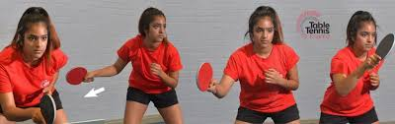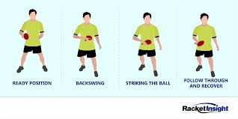

**Top spin**

Closing the angle of the bat. This is an attacking shot as it typically makes the opponent have to move back to hit it due to the high power and bounce.

**Back spin**

Opening the angle of the bat. This is a defensive shot as the shot takes longer to travel to the opponent, giving the defender more time to get back into position.

**Key words:**

**Cross-table:** A ball that is hit diagonally from corner to

corner.

**Dead:** A ball without any spin.

**Drive:** The basic topspin shot or smash executed close to the table.

**Set.** Each game is played to 11 points unless a deuce occurs.

Game Point: Last point of a game.

**Let:** Service ball hitting the net or a distraction that causes the point played over.

**Push:** A push is an underspin shot executed over the table, and usually close to the net. This is a passive shot that is used when it is impossible to attack a ball.

**Rally:** The period in which the ball is in play.

**Shake hand:** The most popular grip. It gives the best balance of forehand and backhand.

**Stroke:** Any shot used in the game, including the serve.

