|  |  |
| --- | --- |
| **Expressive Art** | A form of art which expresses emotions or feelings through the style of the work and the materials used. |
| **Theme** | **In art**, **theme** is usually about life, society or human nature, but can be any other subject. **Themes** are the ideas explored **in** a work. |
| **Emotion** | a strong feeling such as joy, hatred, sorrow, or fear. When one feels an emotion, there are physical changes such as an increase in pulse, crying, or trembling. |
| **Loui Jover** | Loui Jover is an Australian painter and artist. He is known for his artwork in ink wash paintings on vintage book pages. |
| **The Grid Method** | **The grid method** is a way to reproduce and/or enlarge an image that you want to paint or draw. **The grid method** involves drawing **a grid** over your photo, and then drawing **a grid** of equal ratio on your piece of paper. |
| **Primary Colours** | A **primary color** is a **colour** that cannot be made from a combination of any other **colours**. (Red, Yellow and Blue) |
| **Secondary Colours** | A secondary **colour** is a **colour** created from a combination of two **primary colours. (Green, Purple, Orange)** |

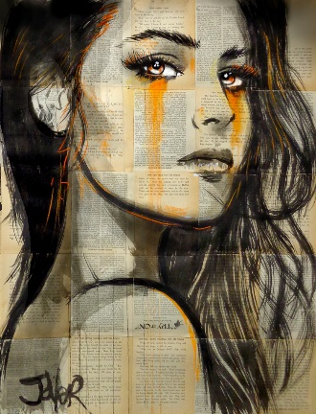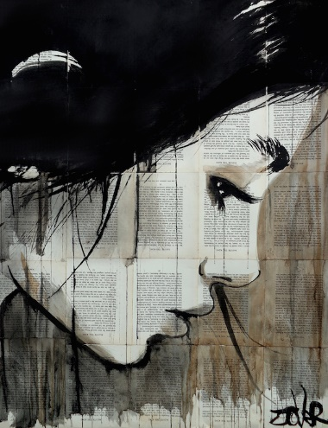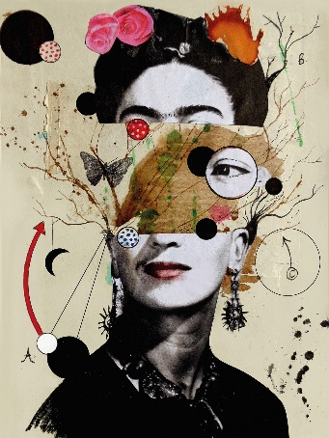

**Explore Expressive Art in a variety of materials: pencil, pen, watercolour, coloured pencils, oil pastels, felt pens.**

**You can copy work from the artists Louis Jover**

**Try making your own expressive art portrait using dripping paint and text**

Expressive

Non-examples

Examples

Characteristics

Definition

**Year 8 Pop Art Portraits**

**Art and Design**