|  |  |
| --- | --- |
| **Nostalgia** | Something done or presented in the past to evoke feelings of longing and happiness. |
| **Observational drawing** | When an artist observes something and responds to it with a visual representation (A drawing) |
| **Tone** | Areas of light and dark used to create a realistic drawing |
| **Shading** | **Shading** is a technique used by artists, to create the illusion of depth. (Make something look 3D) |
| **Texture** | The feel or appearance of a surface. |
| **Highlights** | The lightest parts of your drawing. |
| **Scale & Proportion** | **Scale** and proportion in **art** are both concerned with **size**. **Scale** refers to the **size** of an object. |

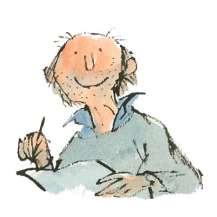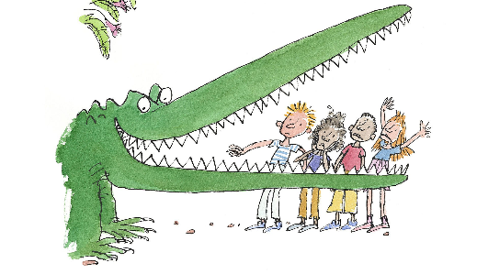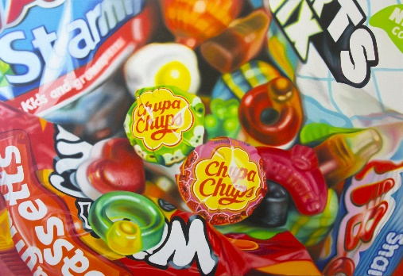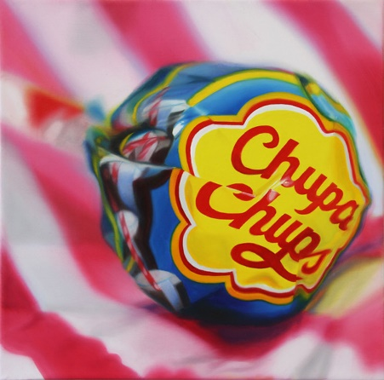

**Explore portraiture in a variety of materials: pencil, pen, watercolour, coloured pencils, oil pastels, felt pens.**

**You can copy the work of Sarah Graham and Quentin Blake**

**Try and copy your own photo realistic sweet drawing or Quentin Blake character.**

Nostalgia

Non-examples

Examples

Characteristics

Definition

**Year 7 Portraiture**

**Art and Design**