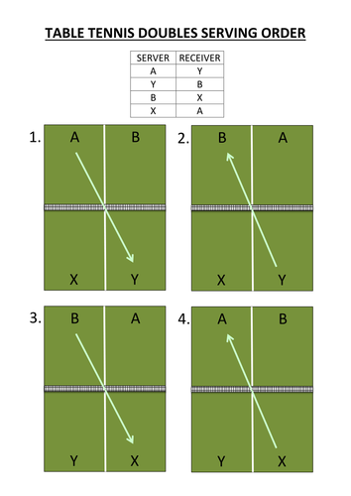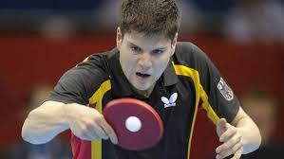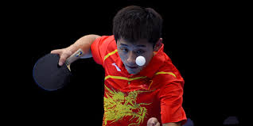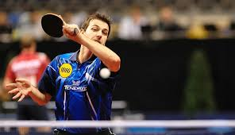

***Putting spin the ball:***

**Forehand spin:**

Feet more than shoulder width apart and bent knees.

Meet ball low, just after the bounce.

Angle bat so its facing toward opponents head.

Bring elbow downwards to cause ball to spin.

**Backhand topspin:**

Feet more than shoulder width apart and bent knees.

Meet ball low, just after the bounce.

Angle bat so it is facing towards the net.

Bring elbow upwards to cause ball to spin.

***Spinning serves***

* Standing with feet wider than shoulder width apart

and body facing away from the table.

* Flex elbow at a 90degree angle.
* “chop” under the lowest part of the ball as you push

forward with the paddle.

***Doubles rules:***

Games are played to 11 points.

3,5 or 7 games can be played.

Serve must travel diagonally over the table but only from right to left. This means that if a player is stood on the right side, they must swap side with their partner.

Serve changes teams every 2 points, this is regardless of who won the point. However, once the score reaches 10 – 10, serve swaps every single point.

**P.E**

**Year 10 Table Tennis**