**Food Labelling- legal requirements:**

* The name of the product​
* Ingredients list​
* Date mark​
* Weight or volume​
* Preparation instructions​
* Place of origin​
* Allergen information​
* Storage conditions​
* Lot (or batch) number/mark​
* Nutrition information​
* Name and address of manufacturer

**Eggs- Nutrients:**

* Easily digested protein needed for growth​
* Essential vitamins, A,D,E, K and B groups – but no vitamin C ​
* Minerals in iron, phosphorus and zinc​
* 80-90 kcal an egg – and they are low in saturated fat

**Safety**

* Sharp knives: never walk around with a knife. Use the *bridge hold* and *claw grip* to cut safely.
* Hot liquid: drain hot liquid carefully over the sink using a colander.
* Saucepans: turn panhandles in from the edge, so they are not knocked.
* Hot equipment: always use oven gloves when placing food in and out of the oven.
* Spills: wipe up immediately.
* Electrical equipment: always follow instructions.

**Allergies and intolerances**

These are the 14 ingredients (allergens) that are the main reasons for adverse reactions to food:

* Celery
* Cereals Containing Gluten (including wheat)
* Crustaceans (such as prawns, crabs and lobsters)
* Eggs
* Fish
* Lupin
* Milk
* Molluscs (such as mussels and oysters),
* Mustard
* Peanuts
* Sesame
* Soybeans
* Sulphur Dioxide and Sulphites
* Tree nuts eg. almonds, hazelnuts

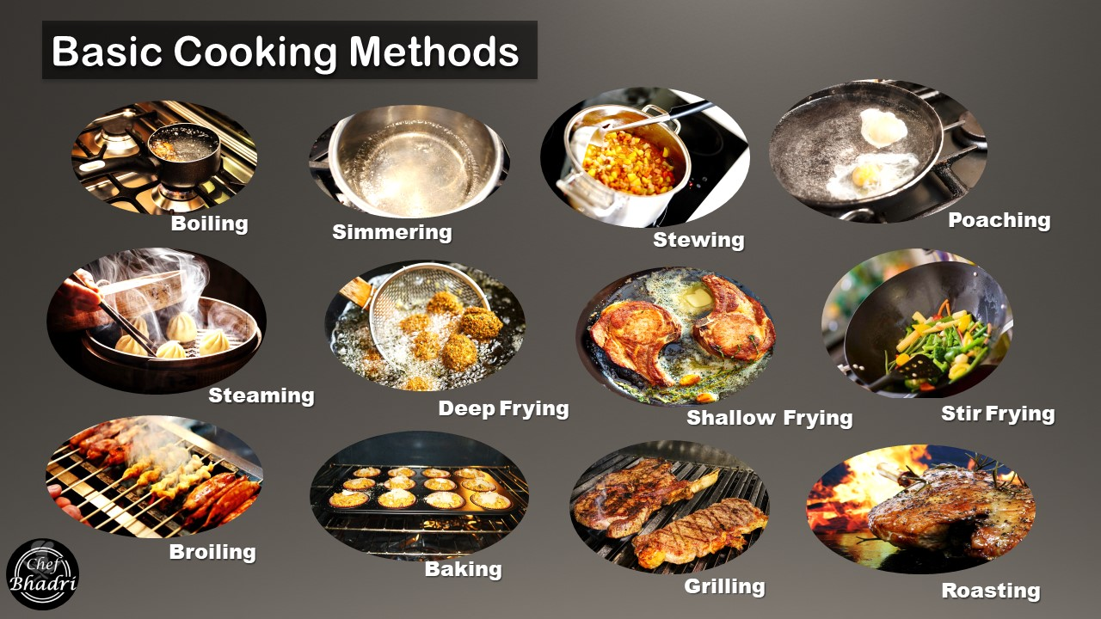

**Y9 Food**

**Year 9 Technology**