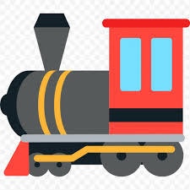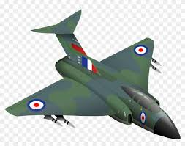

**Dunkirk, 1940**

In May 1940, Germany advanced into   
France, trapping Allied troops on the   
beaches of Dunkirk. Under air and ground cover from British and French forces, troops in the **British Expeditionary Force** were slowly and methodically **evacuated** from the beach in a **fleet** using every available navy and **civilian** vessel they found.

**Changes at home**

***The Blitz***

This continuous bombing of the United Kingdom by Germany between 7th September 1940 - 10th May 1941 became known as the **Blitz**. This **bombing** which targeted innocent **civilians**. London was the main target but other cities were also bombed. **Casualties** were high; first day of bombing 430 people killed and 1,600 badly injured.

***Evacuation***

In light of bombings, vulnerable people who lived in the cities were evacuated to homes in the countryside for their own safety. 827,000 school children were evacuated and their teachers, mothers/children under five and also pregnant women's were moved.

***Rationing***

The Ministry of Food introduced rationing on 8th January 1940. The aim was to regulate food production and usage in light of German efforts to blockade British supplies. There was other rationing on clothing and other consumer goods.

Changing role of women

As more and more men were   
'called up' to serve in the   
armed forces, women were called upon to take over the jobs traditionally done by men. Women worked in factories producing aircraft, ammunitions and other war goods.

**Battle of Britain, 1940** In the summer of 1940, Hitler decided to invade Britain (**Operation Sea lion**). The Luftwaffe began making daily bombing raids on British ships, ports, radar stations, airfields and aircraft factories (**Blitzkrieg). Churchill** addressed parliament in June 1940, famously announcing “the Battle of Britain is about to begin.” **By October 1940 the RAF was victorious. Hitler called off his invasion plans and the Luftwaffe switched to bombing British cities.**

**What caused World War Two?**

***1. Treaty of Versailles – June 1919***

**L**and – Germany lost overseas colonies. Alsace-Lorraine given to France

**A**rms – German army reduced to 100,000, no air force, only 6 battleships.

**M**oney – Reparations set at 6.6billion

**B**lame – Germany had to accept War Guilt Clause.

***2. Hitler’s aims & actions***

***3. Appeasement***

It was a policy of negotiating with Hitler (giving him what he wanted in return for promises) used by British PM Neville Chamberlain

**+** Britain were not prepared for war, Treaty of Versailles unfair, Britain in Depression, League not working

**-**Encouraged Hitler’s aggression, allowed army to grow strong.

**How was World War Two a ‘total war’? 1**

**History**