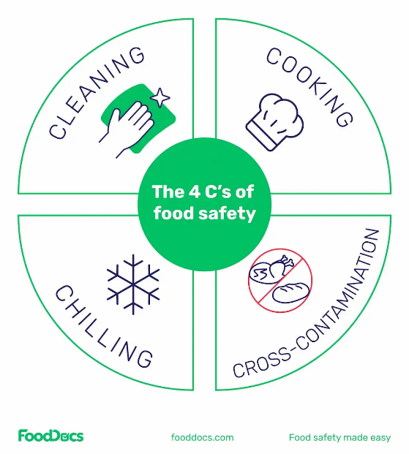

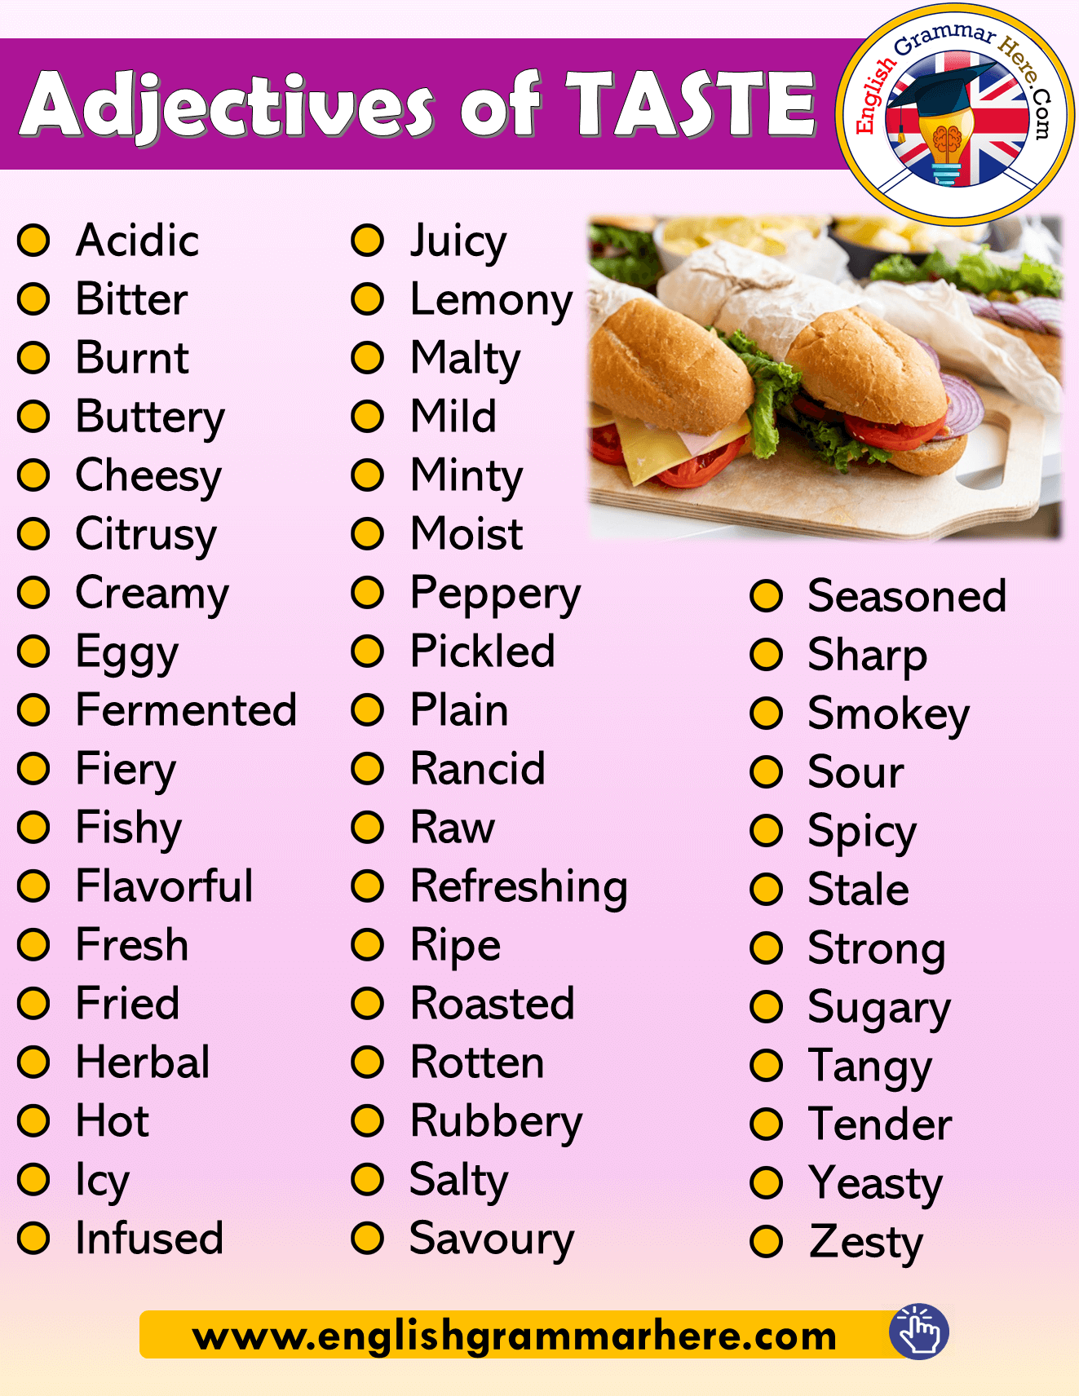

**Safety**

* Sharp knives: never walk around with a knife. Use the *bridge hold* and *claw grip* to cut safely.
* Hot liquid: drain hot liquid carefully over the sink using a colander.
* Saucepans: turn panhandles in from the edge, so they are not knocked.
* Hot equipment: always use oven gloves when placing food in and out of the oven.
* Spills: wipe up immediately.
* Electrical equipment: always follow instructions.

**Bread- Functions of ingredients**

**Flour**: Flour provides the structure and texture of bread. The gluten in flour gives the bread its chewy texture and helps it rise. **Yeast**: Yeast is responsible for the rising of bread dough. It produces carbon dioxide gas, which gets trapped in the dough, causing it to rise.

**Water**: Water is needed to activate the yeast. It also helps to create the steam that is necessary for the crust to develop during baking.

**Salt**: Salt is added to bread dough for flavour and it also strengthens the gluten and helps to prevent the dough from becoming too sticky.

**Sugar**: Sugar is added to bread dough to provide food for the yeast and to help with browning during baking. It also contributes to the flavour of the bread.

**Fats**: Fats, such as butter or oil, are added to bread dough for flavour and to help keep the bread moist.

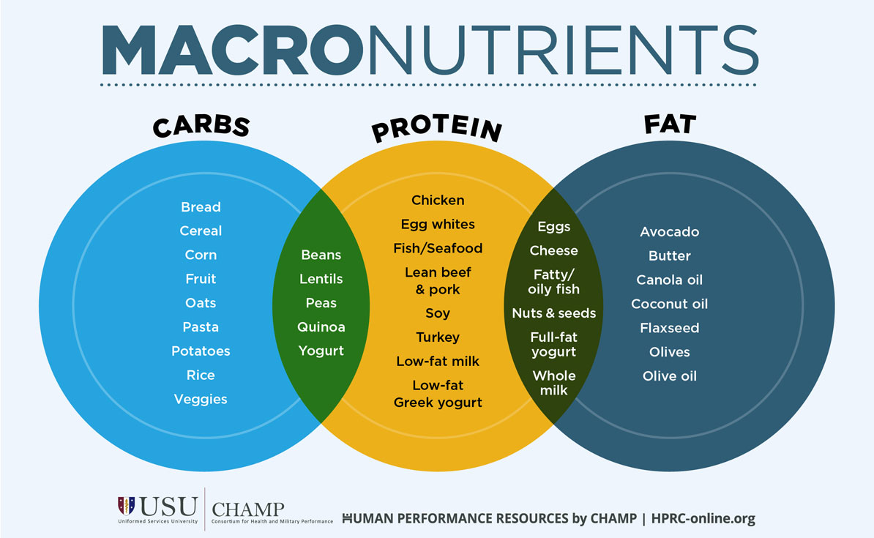

**Diet and health**

There is a link between a poor diet, and the risk of developing some diseases.

This includes the risk of:

* cancer
* coronary heart disease (CHD)
* Osteoporosis
* Iron deficiency anaemia
* Tooth decay
* Type 2 Diabetes

**Y8 Food**

**Year 8 Technology**