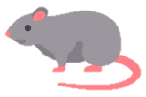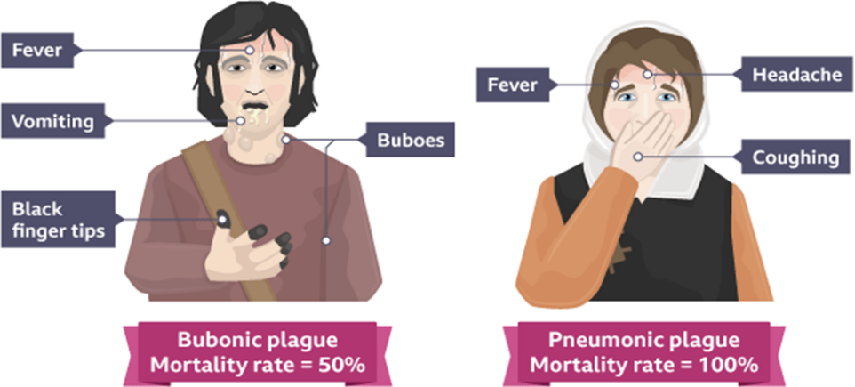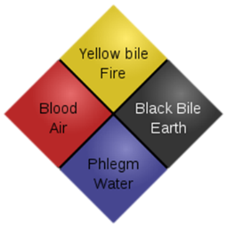

Impact of the Black Death

|  |  |
| --- | --- |
| Short term | Long term |
| * Worldwide: 75 million people killed. * Europe: ½ population killed * Fields and streets littered with bodies. * Not enough workers/farmers= starvation | * Fewer workers= workers demanded for more money * King passed laws to stop wages going up, this led to the Peasants revolt 1381 |

**What did they believe caused the Black Death?**

Natural causes

Miasma caused by the waste and poor sanitary conditions in towns.

An imbalance in the four humours. These were black bile, yellow bile, phlegm and blood.

Supernatural causes

Some people believed God was the cause, as a punishment for people’s sins.

Astrologists believed the cause was the alignment of the planets.

**What actually caused it?**

**Bubonic plague:** spread by rats. If a flea that had bitten an infected rat jumped onto a person and bit them, it would transmit plague.

**Pneumonic plague**: spread from one person to another through coughing or sneezing which spread air droplets containing plague bacteria, affecting the victim's lungs.

**The main symptoms**

**How ‘smelly’ was the Middle Ages?**

|  |  |
| --- | --- |
| Hygienic | Unhygienic |
| * The rich had baths with soap and scented herbs * Gong farmers were sometimes paid to clear filth * People brushed their teeth * Public bathhouses | * Waste was dumped in the water supplies- there was no clean water * Sewage piled up on the streets * People used shared outdoor toilets (privies) * Homes had floor made of straw with animal waste and fat underneath * Many people shared the same bath water in bathhouses |

Many people tried to improve **Public Health.** Although they didn’t know about germs, they thought it was bad smells that caused illness, laws were passed such as 1374 a London council made households pay a fee to have the stream cleaned once a year!

**What was the Black Death?** The Black Death (the Plague) travelled from Asia and hit England in 1348. It killed up to half of the population and was made up of two strands of plague: bubonic and pneumonic. It ended in the early 1350s.

**Treatments**

* **Strapping a chicken’s bottom to the buboes**
* **Popping the boils**
* **Praying to God**
* **Flagellation**
* **Killing cats and dogs**
* **Locking plague victims in their homes**
* **Lighting fires**
* **Moving away**
* **Blood letting**

**How far was the Black Death a disaster?**

**History**