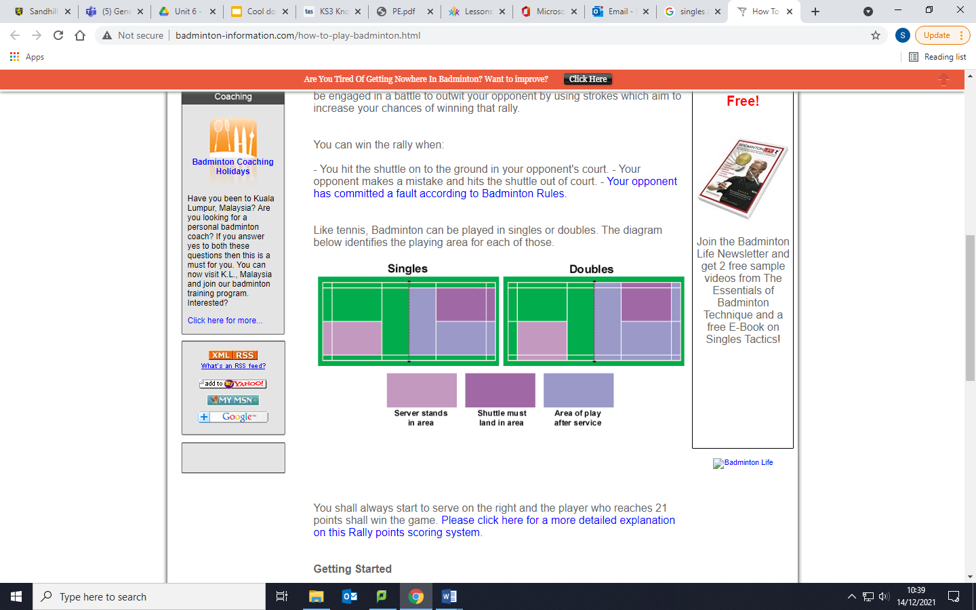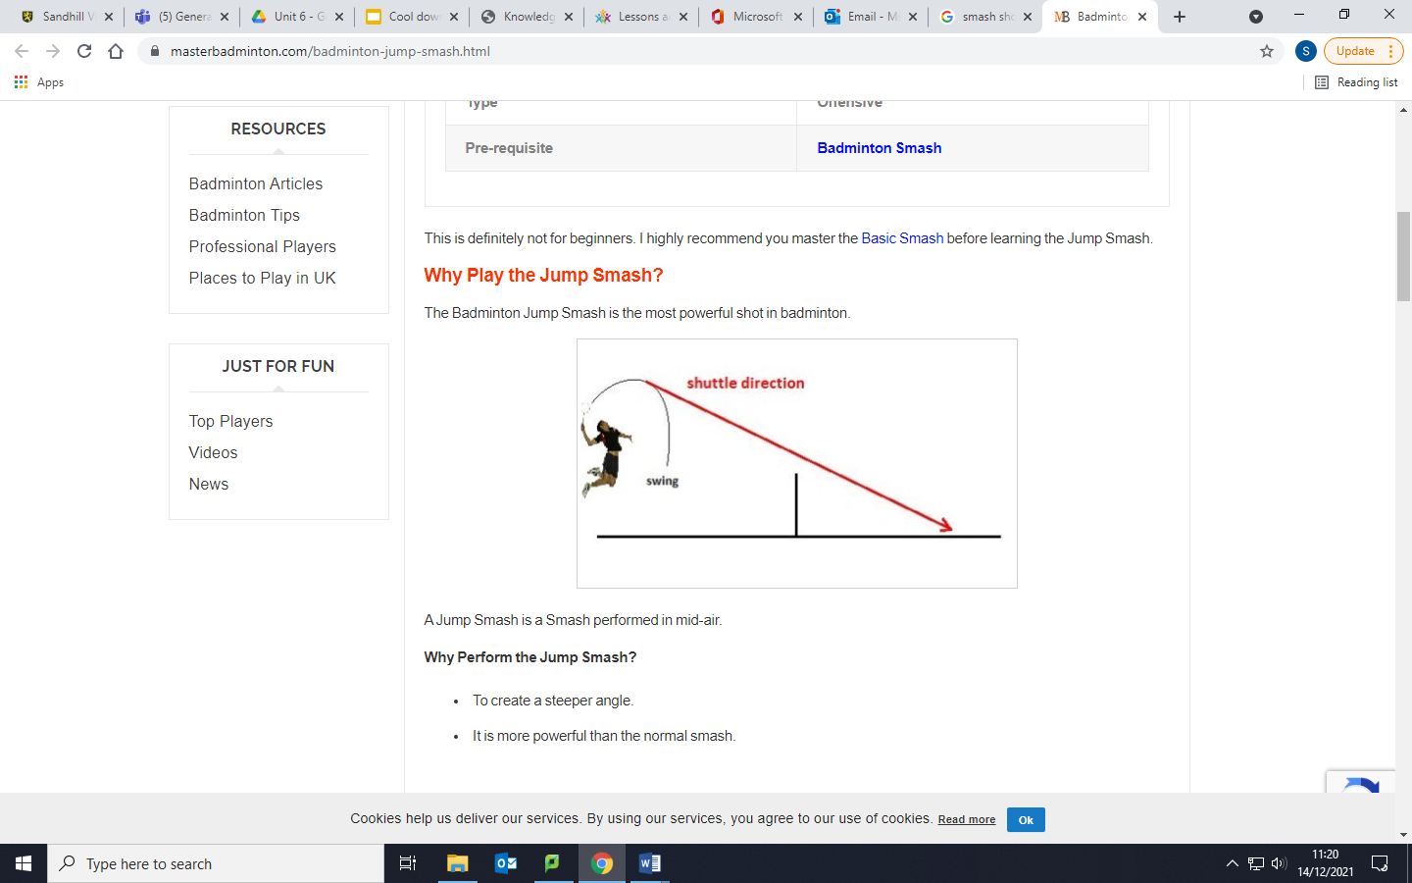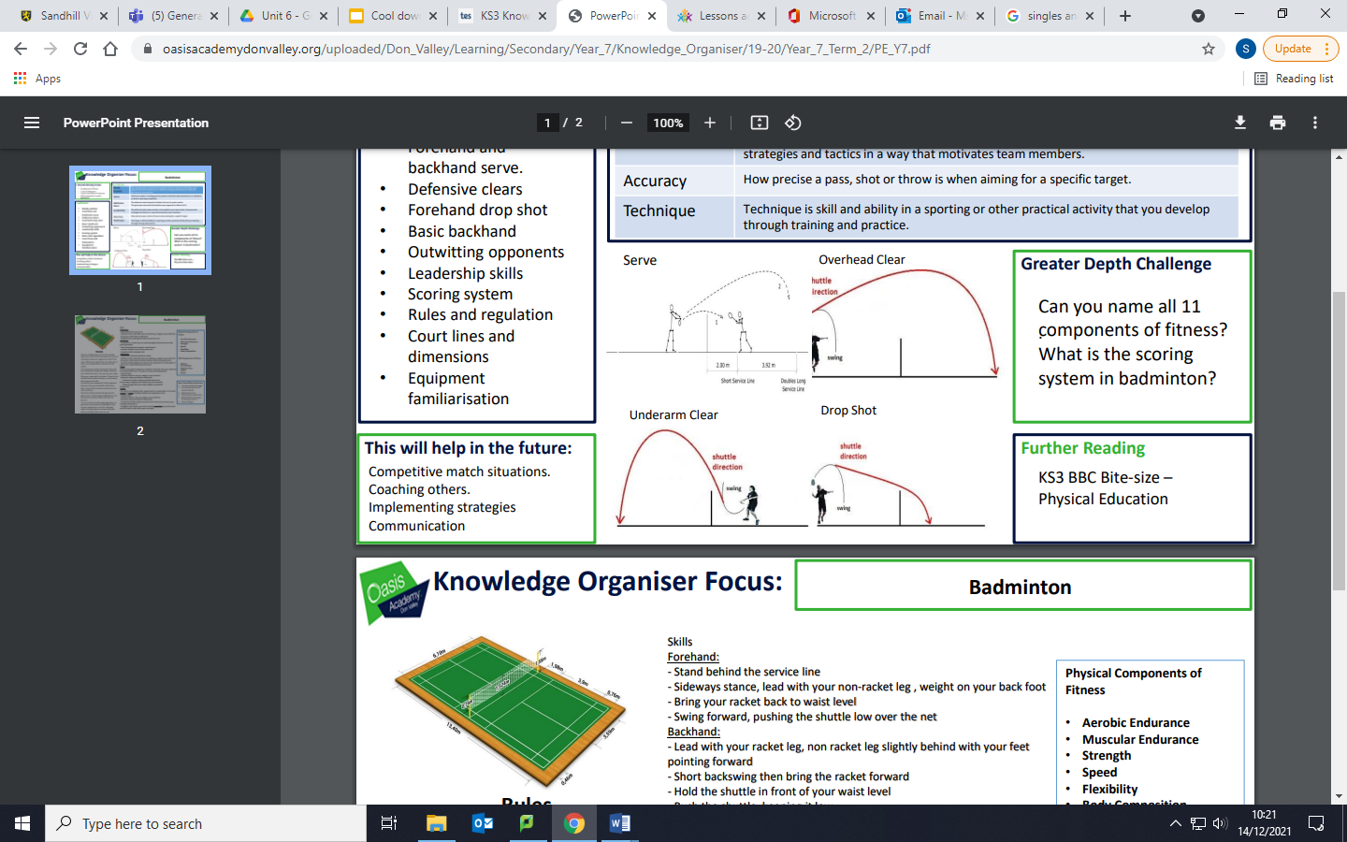

**Components of fitness**

Aerobic endurance

Muscular endurance

Strength

Speed

Agility

Balance

Coordination

Power

Reaction time

**Key skills**

**Serving-** There are several types of serve. Short/backhand, long and flick. The racket head must start from below the waist.

**Underarm clear (long serve) -** This shot is played high to the back of your opponent’s court. Start sideways on and use a whip action with the wrist to create power.

**Overhead clear**- Played to the back of your opponent’s court and is a defensive shot.

**Drop shot-** a shot played with finesse to land the shuttle as close as possible to the net on your opponent’s side.

**Smash/jump smash shot-** This is the main attacking shot in badminton. It is an overhead shot, hit in front of the body. The aim is to get the shuttle down on the floor at a sharp angle. The wrist needs to “snap” to get it down. Jumping to hit the shot gives it more power.

**Badminton court markings**

**Tactics**

**Hitting into space-** moving your opponent around the court

**Shot selection-** selecting the right shot for the right situation

**Targeting your opponent’s weakness-** look out for areas of weakness in their play

**Disguised shots-** Trying to make it look like you are going to play a particular shot but then play a different shot to fool an opponent

**Doubles play**- role of players in doubles. Front/back formations or side to side

**Scoring system**

Every time you win a rally, you get a point. Starting from zero, the first person to reach 21 points wins the games. You have to win the game by at least two points, so if the score is 20-20, then 21 points are no longer enough to win the game and would need to get to 22. When the servers score is an even number, he serves from the right service court. When his score is an odd number, he serves from the left.

**Year 10 Badminton**

**PE**