**Year 9 PE**

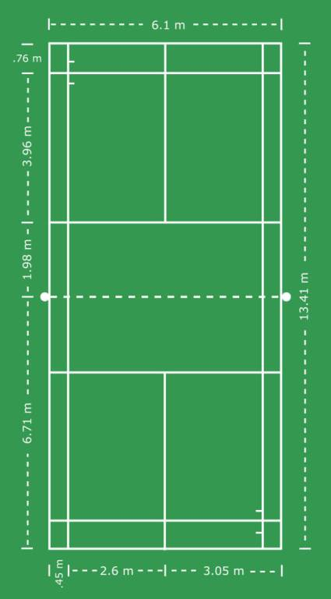

**Badminton**

**Rules of Badminton**

* The game is played to 21 points. If the score reaches 20-20, the winner is the first player or team with a two point advantage.
* If the score goes up to 29-29, the winner is the first to reach 30 points.
* The service must be made diagonally across court.
* The server must serve with the head of the racket below waist height.
* A shuttle landing on the line is in.
* If a shuttle hits the net either on service or during a rally, play continues.
* Players may not make contact with the net with either the racket or their body.
* The shuttle must be contacted on the player’s own side of the net.
* One touch of the shuttle on your own side.

**Singles**

* All serves are taken from the right service court if the score is an even number or zero and from the left service court if the score is an odd number of points.
* Points are awarded to the winner of each rally.
* You lose service if you fail to return the shuttle, hit it out or into the net.
* If the shuttle hits the ground within the boundary the point is awarded to the player who hits the shuttle.

**Doubles**

* In doubles, the players on the right always starts the serve and when a point is won, the players switch sides and then serve from the left alternating until a serve is lost.
* After service the shuttle can be hit anywhere in the entire court.

**Scoring system**

Every time you win a rally, you get a point. Starting from zero, the first person to reach 21 points wins the games. You have to win the game by at least two points, so if the score is 20-20, then 21 points are no longer enough to win the game and would need to get to 22. When the servers score is an even number, he serves from the right service court. When his score is an odd number, he serves from the left.

**Tactics**

The basic principle of tactics is to play “the right shot at the right time”. Tactics will vary according to the level of skills of the players. Tactics are based on:

* Position of the shuttle
* The shot options available in the game
* The reasons for selecting a shot
* The effect of the shot on opponents.

**Badminton Techniques**

* High serve
* Low serve
* Backhand serve
* Smash shot
* Overhead clear
* Net shot
* Drop shot