**Skills:**

**Passing –** Students should start to learn how to pass the ball further distances using the spin pass.

**Catching** – Students should be able to catch a ball competently whilst on the move.

**Tackling** – Students should be able to tackle safely during a competitive scenario.

Students start to look at the different positions and their roles within a rugby match.

**Rugby positions (Rugby League):**

**Backs (Attacking positions)**

* 1 Full back
* 2 Right wing
* 3 Right centre
* 4 Left centre
* 5 Left wing
* 6 Stand-off half
* 7 Scrum half

**Forwards (Defensive positions)**

* 8 Prop (Front Row Forward)
* 9 Hooker or Dummy-half
* 10 Prop (Front Row Forward)
* 11 Second Row Forward
* 12 Second Row Forward
* 13 Lock Forward

**Key Words**

Pass

Tackle

Ruck

Try

Conversion

**Positions (Rugby league)**

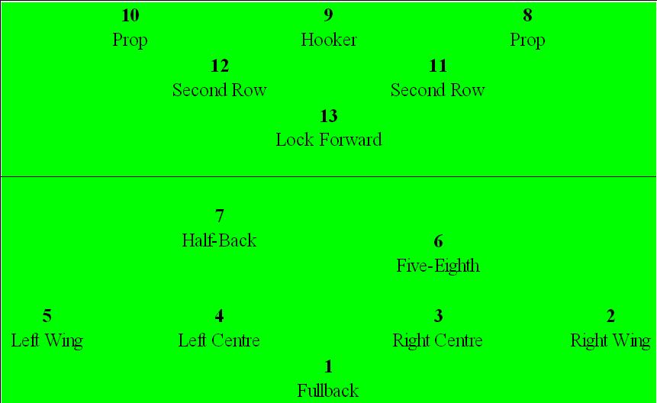

**Rugby – Year 8**

**Physical Education**