**Skills:**

**Passing –** Students should be able to pass the rugby ball using basic technique – ‘6 O’clock 12 0’clock’ which can be used for mainly shorter to medium distances.

**Catching** – Students should be able to catch a ball, creating a ‘W’ with their hands as a target for their teammate to aim for.

**Tackling** – Students should be able to tackle safely and understand the hazards of incorrect technique. Tackling should be performed from below the chest area.

**Rugby Rules**

* 13 or 15 aside – depending on the code (league or union)
* Ball must be passed backwards
* A try is scored if the ball is placed behind or on the opponents try line.
* You are out if any part of your body is on or past the touch line.

**Penalty**

* To endanger an opponent
* To pass the ball forward or if the ball goes forward from any body part other than the foot
* Use other players to prevent defenders from getting to the player with the ball.

**Key Words**

Pass

Tackle

Ruck

Try

Conversion

**Pitch dimensions**

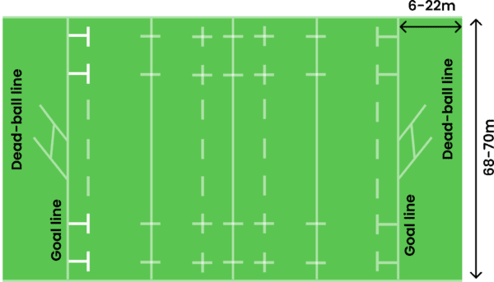

**Rugby – Year 7**

**Physical Education**