|  |  |
| --- | --- |
| **Portrait​** | A painting, drawing, photograph, or engraving of a person, especially one depicting only the face or head and shoulders.**​** |
| **Tone**​ | Areas of light and dark used to create a realistic drawing​ |
| **Shading**​ | **Shading** is a technique used by artists, to create the illusion of depth. (Make something look 3D)​ |
| **Symmetry**​ | Exactly similar parts facing each other​ |
| **Texture**​ | The feel or appearance of a surface. ​ |
| **Highlights**​ | The lightest parts of your drawing. ​ |
| **Scale & Proportion**​ | **Scale** and proportion in **art** are both concerned with **size**. **Scale** refers to the **size** of an object.​ |

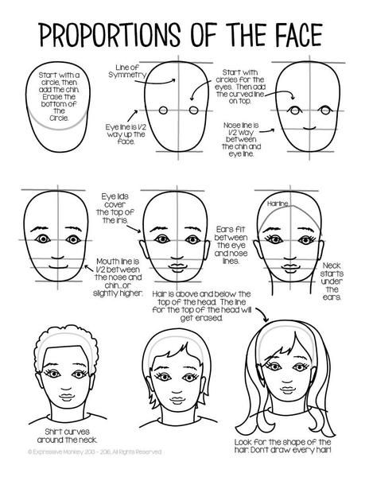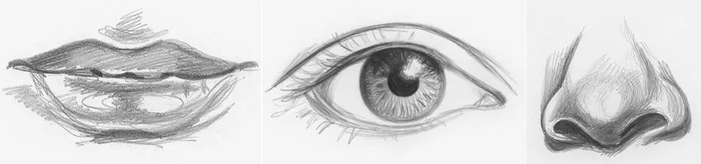

**Explore portraiture in a variety of materials: pencil, pen, watercolour, coloured pencils, oil pastels, felt pens.**

**You can use online tutorials to help you develop your skills and choose your favourite technique!**

**Try a self-portrait or a portrait of a celebrity using the guidelines to the left to help with proportion**

Non-examples

Examples

Characteristics

Definition

Portraiture

**Year 7 Portraiture**

**Art and Design**