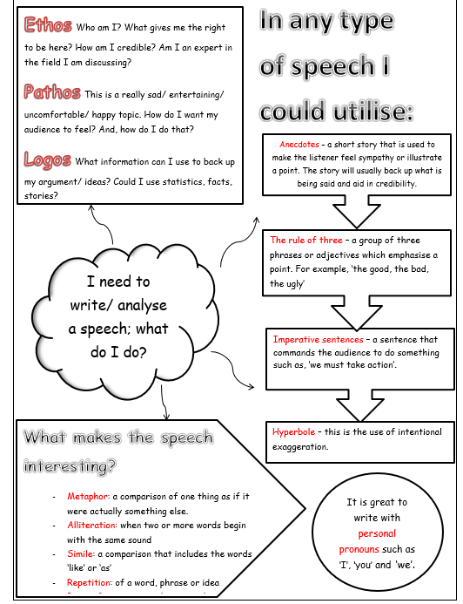

**Paragraph 1** – ‘Imagine’ – Present the worst-case scenario

**Paragraph 2** – Evidence – Evidence the problem using facts/statistics/ expert opinions

**Paragraph 3** – Consequences – What will happen if the problem isn’t addressed now? Use hyperbole.

**Paragraph 4** – Solutions – What needs to be done to improve the situation? Use imperative verbs and forceful phrases.

**Paragraph 5** – ‘Imagine’ – Present the ideal scenario if all actions are taken.

How can I structure my speech to make it effective?

During Spring 1, we will be reading and analysing a range of speeches as well as crafting our own.

**Y8 – Speeches**

**English**