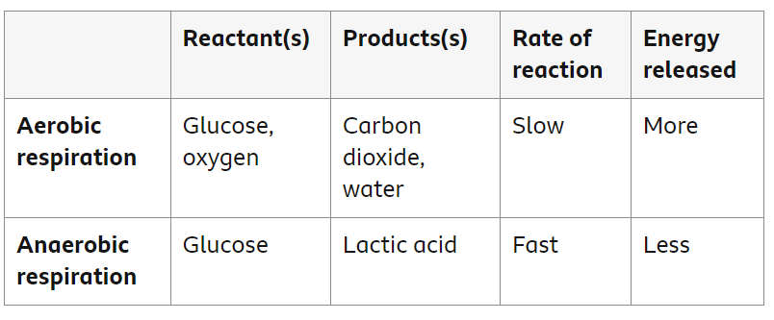

**Fermentation**

Some bacteria and fungi such as yeast complete their own version of anaerobic respiration called fermentation. This is the equation:

Glucose -> ethanol + carbon dioxide

Yeast undergoes fermentation when bread and beer is made. Ethanol is the alcohol produced. This is evaporated away when bread is baked. Carbon dioxide gas trapped in bread makes it rise and gives beer its bubbles.

**Oxygen Debt**

During exercise, more energy is required by the body than when resting, due to increased muscle contractions. The body reacts to this increased demand for energy by: • The heart rate, breathing rate, and volume of each breath all increase. • Together, these increase the amount of oxygenated blood reaching the muscles. • The oxygenated blood provides the extra oxygen and glucose needed for respiration in muscle cells, to release more energy to meet demand.

**Oxygen Debt**

After vigorous exercise, people continue to breathe deeply and quickly for a short period. This is called excess post-exercise oxygen consumption or EPOC. It used to be called ‘oxygen debt.’ During this time, the lactic acid reacts with oxygen to form carbon dioxide and water, and releases the rest of the energy originally in the glucose.

**Anaerobic Respiration**

For a short period during vigorous exercise, the body’s cells may not have enough oxygen. This means aerobic respiration cannot occur and anaerobic respiration happens instead.

Anaerobic respiration releases less energy than aerobic respiration but it does this faster. The product of this reaction is lactic acid. This builds up in muscles causing pain and tiredness, which can lead to a cramp.

Glucose -> Lactic Acid

**Respiration**

Respiration is a chemical reaction which occurs in every one of the cells in the human body. It releases energy stored in glucose and without it, these cells would die.

**Aerobic Respiration**

Aerobic respiration slowly releases lots of energy stored in glucose. It mostly occurs in tiny parts of your cells called mitochondria which are found in the cytoplasm.

Oxygen + Glucose -> Carbon Dioxide + Water

**Key Vocabulary**

**Breathing**

The movement of air in and out of the lungs

**Respiration**

The chemical reaction which occurs in all living cells, releasing energy from glucose

**Aerobic**

Respiration that uses oxygen

**Anaerobic Respiration**

Respiration that occurs when there is not enough oxygen

**Fermentation**

Anaerobic respiration that is completed by yeast.

**Mitochondria**

An organelle where respiration occurs

**Ambitious Vocabulary**

Mitochondria, fatigued, oxygen debt

**Y8 Respiration**

**Science**