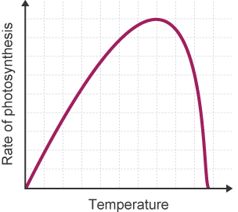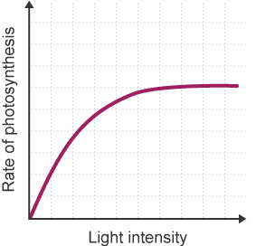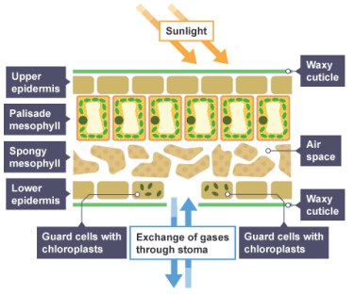

**Temperature**

If it is too cold, the rate of photosynthesis will decrease as the enzymes can’t work effectively. Equally plants cannot photosynthesise if it gets too hot as this causes their enzymes to *denature*

**Carbon Dioxide**

If there is too little carbon dioxide, the rate of photosynthesis will slow down. Carbon dioxide may be limited in enclosed spaces. Plants can still run out of carbon dioxide in a greenhouse on a sunny day where there is plenty of light energy available.

**Light Intensity**

Low light intensity would slow down the rate of photosynthesis as light provides the energy for the process of photosynthesis.

**Limiting Factors**

A plant’s rate of photosynthesis is affected by factors such as light intensity, the concentration of carbon dioxide and the temperature of its surroundings.

A limiting factor is something that constrains the growth or abundance of any organisms or population.

Photosynthesis slows down or stops if the conditions aren’t sufficient enough.

**Ambitious Vocabulary**

Lower epidermis, waxy cuticle, stomata

**Key Vocabulary**

**Chloroplasts**

An organelle that is where photosynthesis occurs

**Chlorophyll**

A green pigment which absorbs light for photosynthesis

**Photosynthesis**

A process that occurs in the leaves of a plant that produces glucose using light energy

**Palisade layer**

A layer has the most chloroplasts to carry out photosynthesis

**Upper Epidermis**

Allows light through to the palisade layer so photosynthesis occurs

**The Leaf**

Palisade layer has the most chloroplasts to carry out photosynthesis.

Stomata let carbon dioxide into the leaf.

Upper epidermis allows light through for photosynthesis.

The whole leaf has a large surface area to absorb sunlight.

**Photosynthesis**

Carbon Dioxide + Water -> Oxygen + Glucose

Photosynthesis takes place inside plant cells in small objects called chloroplasts. Chloroplasts contain a green substance called chlorophyll. This absorbs the light energy needed to make photosynthesis happen. Plants and algae can only carry out photosynthesis in the light.

Plants get carbon dioxide from the air through their leaves, and water from the ground through their roots. Light energy comes from the Sun.

The oxygen produced is released into the air from the leaves. The glucose produced can be turned into other substances, such as starch and plant oils, which are used as an energy store. This energy can be released by *respiration.*

**Photosynthesis**

Photosynthesis is a process that occurs in the leaves of a plant and needs both chlorophyll and light energy. During photosynthesis, the chlorophyll in leaves help convert carbon dioxide and water into the products oxygen and glucose. The product glucose acts as a vital source of food for the plant. Carbon dioxide, water and light are all needed for photosynthesis to take place.

**Y8 Photosynthesis**

**Science**