Part | Function
Trachea | This is also called the windpipe. This tube runs from the mouth, down the throat towards the lungs. It is lined with rings of cartilage which keep it open at all times.
Bronchus | The trachea splits into a left and right bronchus each leading to a lung
Bronchi | Each bronchus splits again and again into thousands of smaller tubes called bronchioles which takde the air deeper into the lungs
Alveoli | At the end of the bronchioles are tiny air sacs called calveoli. Here oxygen moves into the blood and carbon dioxide moves out
Intercostal muscles | These muscles run between then ribs and form the chest wall. They contract and relax with the diagrapgm when a person breathes
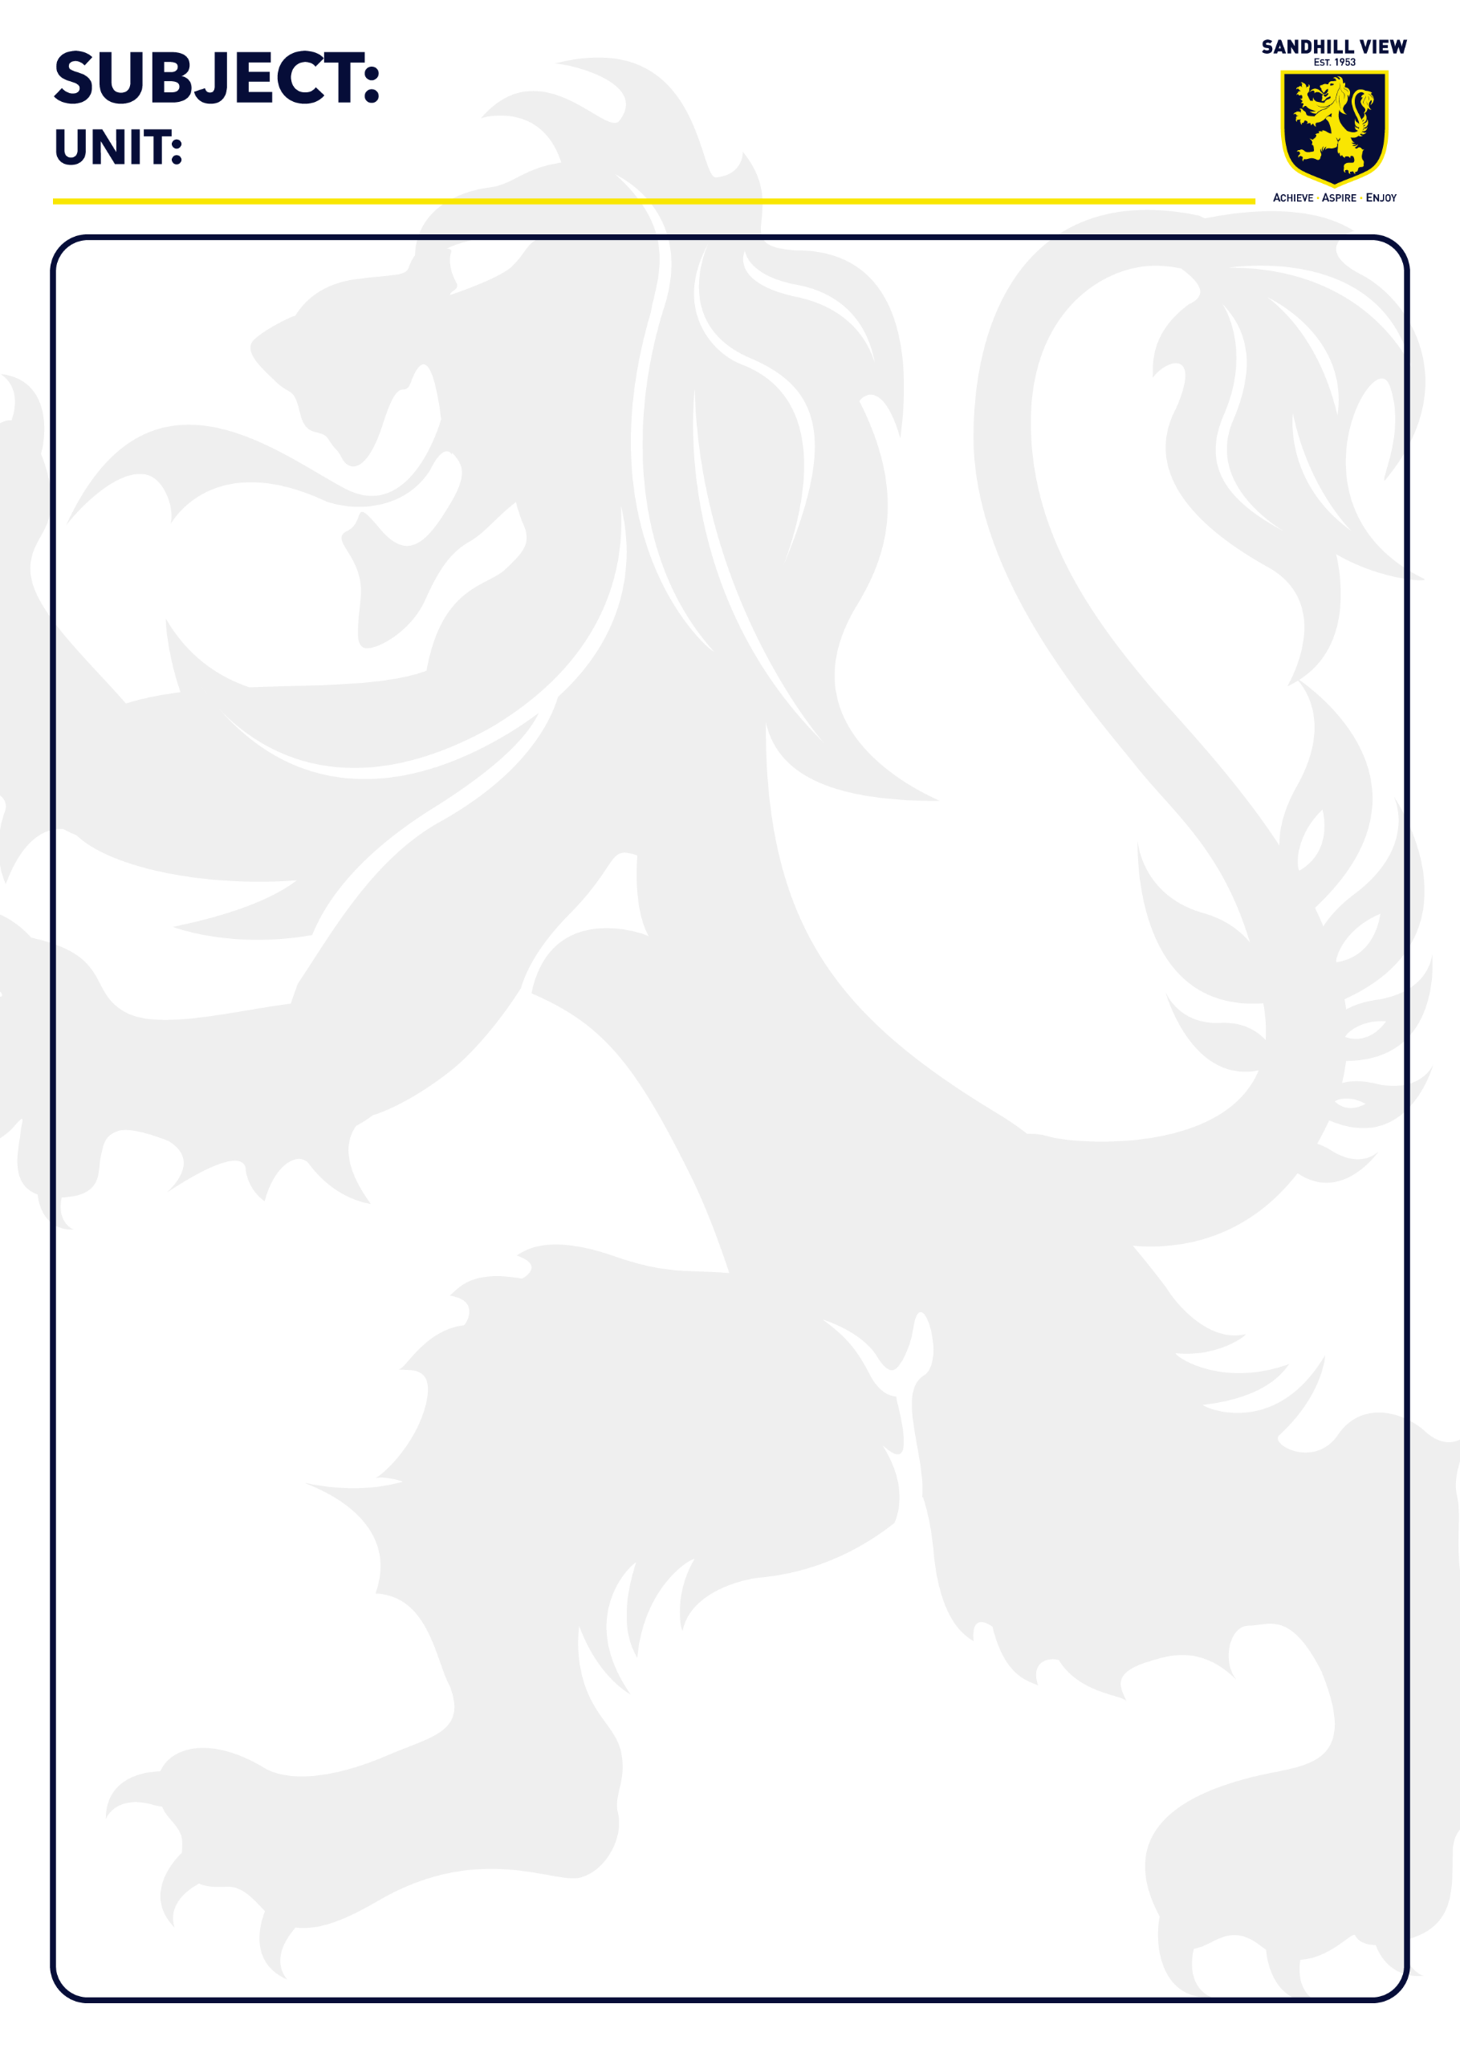
Alcohol
Alcohol is a depressant. It is also addictive. People addicted to alcohol are known as alcoholics. Drinking alcohol during pregnancy can lead to foetal alcohol syndrome in the baby which is a lifelong disorder.
Smoking
Cigarettes contain nicotine which is addictive. They also contain other chemicals known as carcinogens which can cause cancer.
Drugs
Drugs are chemicals that cause a change in the body. Recreational drugs are taken for fun and can be illegal. Medicines are drugs prescribed by medical professionals.
Respiratory System
Air is inhaled into the lungs through the nose/mouth and down a tube known as the trachea. The trachea splits into two tubes; the bronchi. Each of these splits into smaller tubes; the bronchioles. At the end of the bronchioles are air sacs known as the alveoli. This is where gas exchange occurs.
Inhalation requires the intercostal muscles in the chest to contract and the diaphragm to relax so that air can be drawn into the lungs. Exhalation is the opposite.
Diffusion
When a substance moves from an area of high concentration to low concentration until the particles are evenly spread.
Gas Exchange
Oxygen enters the body through the lungs and is diffused into the blood in the alveoli in the lungs. At the same time carbon dioxide is diffused into the lungs from the blood and then exhaled. The alveoli are adapted for gas exchange by having a large surface area and being very thin as well as being covered in small blood vessels. Oxygen is used in respiration to release energy and carbon dioxide is produced.
Key Vocabulary
and stomach
Trachea
Tube that air travels down, connects the mouth and lungs
Alveoli
Air sacs in the lungs where gas exchange occurs
Respiration
Chemical reaction that occurs in all cells and releases energy
Absorbed
When a substance is taken in
Digestion and Breathing
Humans exchange gases and take in nutrients through diffusion.

Y8 Breathing
Ambitious Vocabulary
Gas exchange, diffusion, alveoli
Science

