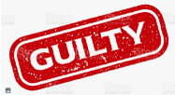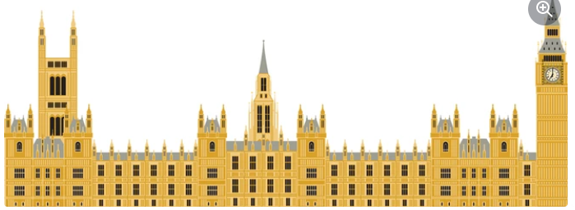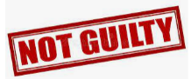

**Richard is guilty:**

- Richard was heir to the throne in the event of the boy’s deaths. Some think this caused Richard to murder the boys.

- Bones were found under the Tower of London, which were believed to have belonged to the Princes. A service was held after this where the Archbishop of Canterbury said: “Their fates at the order of Richard III grieves us”

**Richard is not guilty:**

- When Henry Tudor became king, he gave land and important jobs to James Tyrell, John Dighton and Miles Forest (men who are claimed to have been responsible for the murders of the two princes).

- There were rumours at the time. Some said the two boys had fallen off a bridge and that Prince Edward had become ill and died naturally

**Creation of Parliament**

King John died in 1216. His 9-year-old son Henry became King. When Henry III became old enough to rule without advisors in 1234 problems began; He annoyed the Barons by losing wars, interfering with the Church and asking for high taxes.

**As a result,** in 1258 the barons forced him to sign the *Provisions of Oxford***.** Henry now had to meet with barons every three years to explain his decisions. However, Henry III confronted the barons – the Battle of Lewes broke out.

Unfortunately, for Edward, the barons’ army, led by Simon de Montfort won and he saw his chance to reduce the king’s power even more and, in 1265, he set up Parliament. Although Parliament was to give Barons more power, in the long-term it has become a vital part of democracy - ordinary people now have influence in politics.

**Henry II & Thomas Becket**

Desperate to gain power over The Church, after the Archbishop of Canterbury died (Head of the Church in England), King Henry II put forward his best friend Thomas Becket to fill the position.

**However,** Becket and Henry began to disagree on matters – Becket disagreed when Henry tried to pass a ruling, which meant that Priests had to be tried in the King’s court rather than the Churches. Henry II found Thomas guilty of treason so he fled to France.  In 1170, the Pope threatened to excommunicate Henry (kick him out of the Church), so Henry let Becket back into the country. In rage, Henry is said to have shouted, “Will no one rid me of this turbulent priest?” Four knights heard this and, in a misplaced effort to please Henry, rode to Canterbury, and murdered Becket at the altar of the Cathedral on 29 December 1170.

**Magna Carta & King John I**

The Barons were annoyed at King John for various reasons including: *his military losses in France, setting high taxes and the fact his brother (Richard of Lionheart) had been much more liked and military successful than him*.

**As a result**, they drew up a list of 63 clauses (rules) for John to accept when they met at Runnymede in June 1215. Some of these rules include:

-Not to imprison nobles/barons without trial

-To stop unfair taxes

-Not to interfere with the Church

-The Barons can take the King’s land and castles if he breaks the Charter.

*Many argue the Magna Carta was significant because it was the first time law had been written down. However, the original version only effected rich ‘freeman’ (people below the barons on the Feudal System were not free!)

**Who had power in the Middle Ages?**

**History**