**The Eatwell Guide**

* Comprises 5 main food groups.
* Is suitable for most people over 2 years of age.
* Shows the proportions in which different groups of foods are needed in order to have a well-balanced and healthy diet.
* Shows proportions representative of food eaten over a day or more.

**Where should food be stored in the fridge?**

**Cheese, dairy and egg-based products**

The temperature is usually coolest and most constant at the top of the fridge, allowing these foods to keep best here.

**Cooked meats**

Cooked meats should always be stored above raw meats to prevent contamination from raw meat.

**Raw meats and fish**

Raw meats and fish should be below cooked meats and sealed in containers to prevent contamination.

**Salad and vegetables**

These should be stored in the drawer(s) at the bottom of the fridge. The lidded drawers hold more moisture, preventing the leaves from drying out.

**Eating the seasons**

Most foods are grown in a particular season of the year, e.g. strawberries are harvested in summer in the UK. These are called ‘seasonal foods’.

Buying foods when they are in season will often mean that the price is lower.

Technology and the importation of food has allowed food to be available all year round.

Frozen foods, such as vegetables, are a great alternative to fresh, if they are unavailable.

Claw Grip

Bridge Hold

**Safety**

* Sharp knives: never walk around with a knife. Use the *bridge hold* and *claw grip* to cut safely.
* Grater: hold grater firmly on a chopping board. Grate food in one direction and leave a small amount at the end to prevent injury to knuckles.
* Hot liquid: drain hot liquid carefully over the sink using a colander.
* Saucepans: turn panhandles in from the edge, so they are not knocked.
* Hot equipment: always use oven gloves when placing food in and out of the oven.
* Spills: wipe up immediately.
* Electrical equipment: always follow instructions.

**8 tips for healthier eating**

These eight practical tips cover the basics of healthy eating, and can help you make healthier choices.

1. Base your meals on starchy carbohydrates.
2. Eat lots of fruit and veg.
3. Eat more fish – including a portion of oily fish.
4. Cut down on saturated fat and sugar.
5. Eat less salt (max. 6g a day for adults).
6. Get active and be a healthy weight.
7. Don’t get thirsty- stay hydrated.
8. Don’t skip breakfast.

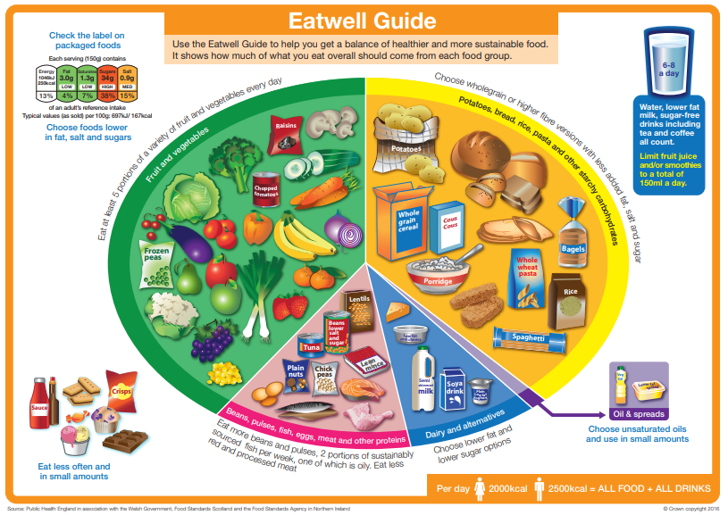





**Y7 Food**

**Year 7 Technology**