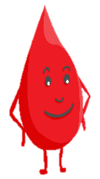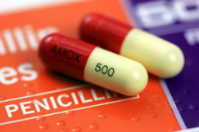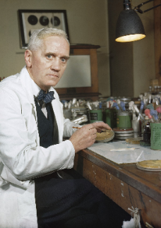

**History**

**Health through time- 20th Century**

**H**

**HllHistory**

**Impact of WWI&WWII on surgery BIP**

***WAR= NEW INJURIES +  
 NEW WEAPONS= NEW DISCOVERIES*.** X-rays and portable machines = doctors see shrapnel and broken bones, without cutting people open.

1901- Karl Landsteiner had discovered blood groups =blood transfusions.

1938- Advances in storage mean the National Blood Transfusion Service opened.

1921 -Harold Gillies developed plastic surgery to help men who suffered severe facial wounds. In WW2 his cousin Archibald McIndoe did further work on faces and hands.

Heart surgery progressed-Dwight Harken who operated on 134 hearts with no fatalities. Since the war there have been kidney, heart, lung, liver and facial transplants- with treatments to stop organ rejection. DNA and stem cells are being mapped and used to grow new organs.

**Public Health:** Poverty was highlighted by the Boer War of 1899-1902 - 40% of the men who volunteered were not fit for military service. This was supported by the work of Booth and Rowntree. Booth wrote that 30% of the population lived in poverty despite many working. Liberal Party came to power in 1906 and passed reforms e.g. 1906 - Free School Meals and 1911 - the National Insurance Act.

In 1942 the Beveridge Report said that people had the right to be free of the ‘five giants’; Disease, want (need), ignorance, idleness, squalor (very poor living conditions).

The Labour Party set up the Welfare State to care for people ‘from the cradle to the grave’. The NHS began in 1948 initially with completely free health care. The NHS budget in 2015-2016 was £116 billion. In the C21st the government continues to try and improve health - 2006 a smoking ban was passed in public places extended to cars in 2015. 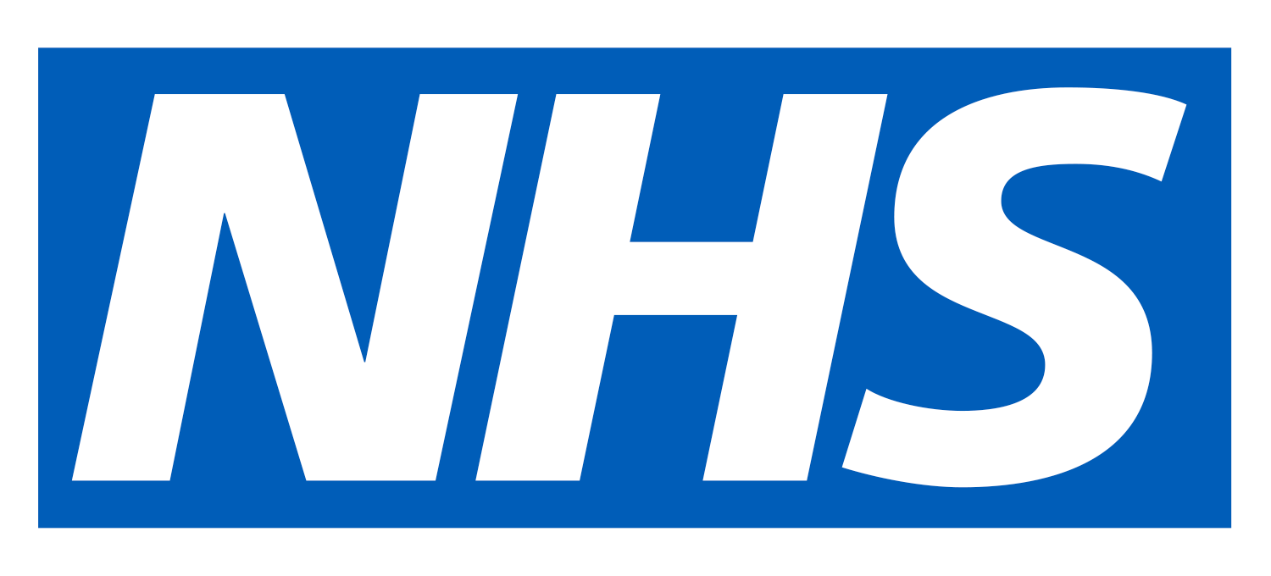

**Alternative Medicine:** People began to distrust drugs and therefore looked for alternatives.e.g. Hydrotherapy, aromatherapy, hypnotherapy and acupuncture.

Today health shops are highly popular with the public who still look for more pure and natural treatments .However, many professionals are against alternative medicine describing such treatments as ‘witchcraft’ and ‘nonsense’

**Alexander Fleming**

**•**Discovered Penicillum mould killed bacteria after he went on holiday, left his lab window open and some of the mould landed on an old petri dish.

•He tried to purify the mould but could not find a way to do this so wrote about his findings in a medical journal.

•Identified that Penicllium mould killed bacteria.

•Led to Florey and Chain reading about his discovery who then went on to purify the mould and prove it worked to kill infection.

**Penicillin- Florey & Chain**

•Read about Fleming’s discovery and decided to test theory of penicillin by purifying the mould.

**Experiment**

Eight mice were infected with bacteria, which would kill them in 24 hours. Four were given penicillin. The four treated mice stayed healthy – but the other four died!

•Purified enough to test on a human-but it needed to be mass produced for humans. They took findings to America to mass produce with support of the government as they were not supported by UK Government as couldn’t prove it worked. They were supported by USA Government because of WW2.

**Impact:**

•Death rates from surgery decreased.

•Deaths from infection decreased.

•Saved thousands of lives during D-Day.

**Impact today:**

•Most widely used antibiotic in the world.