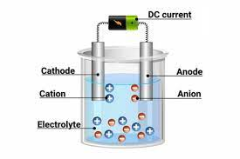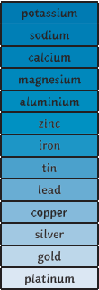

**Ambitious Vocabulary**

Acid, base, Redox, electrolysis

**Making soluble salts**

Pour 40 cm3 of 1.0M sulphuric acid into 100 cm3 beaker

Add the Copper oxide to excess one spatula at a time, stirring using the glass rod as you add it.

Filter the solution into a conical flask and then pour some of the solution into the evaporating dish.

Make a water bath using a beaker. Place the evaporating dish on top of it and then heat until about half the solution has evaporated.

Allow to cool then transfer the solution to a labelled Petri dish and leave in a warm place to finish crystallising.

**Strong and Weak acids**

A strong acid completely dissociates in a solution

e.g. HCl 🡪 H+ + Cl-

Hydrochloric acid is able to completely dissociate in solution to form hydrogen and chloride ions.

Weak acids in comparison only partially dissociate. For example acetic acid partially dissociates to form a hydrogen and acetate ion.

CH3COOH 🡪 CH3COO- + H+

**The process of electrolysis**

Electrolysis is the splitting up of an ionic substance using electricity.

Two electrodes are required to be placed in the electrolyte. The electrodes are conducting rods. One of the rods is connected to the positive terminal and the other to the negative terminal. The electrodes are inert (this means they do not react in the reaction) and are often made from graphite or platinum.

During the process of electrolysis, opposites attract. The positively charged ions will be attracted toward the negative electrodes, the charges are lost and they become elements.

The positive electrode is called the anode.

The

negative

electrode is

called the

cathode.

**Reactions of acids**

The main general formulas for acid reactions are…

Metal oxide + Acid → Metal salt + Water

Metal + acid → Metal salt + Hydrogen

Metal hydroxide + Acid → Metal salt + Water

Metal Carbonate+ Acid → Metal salt + Water + Carbon Dioxide

**Naming salts**

The first part comes from the metal in the carbonate, oxide or hydroxide. The other part comes from the acid.

|  |  |
| --- | --- |
| Acid Used | Salt formed |
| Hydrochloric Acid HCl | Metal Chloride XCl |
| Sulfuric Acid H2SO4 | Metal Sulfate XSO4 |
| Nitric Acid HNO3 | Metal Nitrate XNO3 |

**Electrolysis of aqueous solutions**

Gases may be given off or metals deposited at the electrodes. This is dependent of the reactivity of the elements. Is the metal is more reactive than hydrogen in the reactivity series, then hydrogen will be produced at the negative cathode., At the positive anode, negatively charged ions lose electrons. This is called oxidation and you say that the ions have been oxidised.

**Using electrolysis to extract metals**

Metals are extracted by electrolysis if the metal in question reacts with carbon or if it is too reactive to be extracted by reduction with carbon.

Aluminium is manufactured by the process of electrolysis. Aluminium oxide has a high melting point and melting it requires a large amount of energy (increasing the cost) There fore molten cryolite is added to aluminium oxide to lower the melting point and thus reduce the cost.

**pH scale**

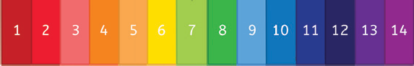

In aqueous solutions, acids produce H+ ions and alkalis produce OH- ions. Neutral solutions are pH7 and are neither acids or alkalis.

H+ + OH- 🡪 H2O

**Redox reactions**

When metals react with acids they undergo a redox reaction. A redox reaction occurs when both oxidation and reduction take place at the same time.

Oxidation is lose of electrons. OIL

Ca 🡪 Ca2+ + 2e-

Reduction is gain of electrons RIG

2H+ + 2e- 🡪 H2

**Reactions of metals with water.**

Metals, when they react with water, produce a metal hydroxide and hydrogen.

Lithium + water 🡪 Lithium hydroxide + hydrogen

Hydrogen

carbon

**Reactivity series**

The reactivity series is a league table for metals. The more reactive metals are near the top of the table with the least reactive near the bottom. In chemical reactions, a more reactive metal will displace a less reactive metal.

**C4 Chemical changes**

**Science**