**Key Equations**

**Density**

$$ρ=\frac{m}{V}$$

**Specific Latent Heat**

$$E=m x L$$

**Pressure**

$$P x V=constant$$

**Quantities and units**

ρ = Density (kg/m3)

m = Mass (kg)

V = Volume (m3)

E = Energy (J)

L = Specific Latent Heat (J/kg)

P = Pressure (Pa)

**Motions in gas particles**

Gas particles move about randomly, at high speed. They collide with each other and the walls of their container exerting a force and therefore pressure. Increasing the temperature increases the kinetic energy and therefore the speed of particles. This increases the collisions and pressure.

**Specific Latent Heat**

**Heating graph:**

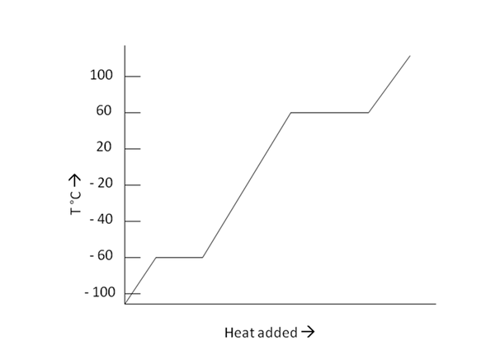

As energy is increased through heating the temperature of the substance also increases as particles move faster. This is shown by the diagonal line.

Where the line becomes flat, energy is still increasing however the temperature remains constant as the potential energy increases instead of the kinetic energy. This represents a change of state.

The internal energy of the substance is increasing throughout the graph.

**Pressure in Gases**

Heating a gas provides more kinetic energy leading to more collisions and therefore a higher pressure. Volume and pressure are inversely proportional, when one increases, the other decreases.

**Specific Latent Heat**

Specific latent heat of fusion - the amount of energy required to get 1kg of a substance to change between a solid and a liquid.

Specific latent heat of vaporisation – the amount of energy required to get 1kg of a substance to change between a liquid and a gas.

**Conservation of Mass**

Mass can never be created or destroyed. Particles can rearrange during chemical or physical changes however the number of particles in a system always remains the same.

**Changing State**

The process of changing between a solid and a liquid is melting (solid to liquid) or freezing (liquid to solid). The process of changing between a liquid and a gas is evaporating, boiling (liquid to gas), or condensing (gas to liquid). When a substance changes state there is no chemical change, only physical. No new substance is formed and the substance can return to its original state. The number of particles remains the same and the mass is conserved.

**Internal Energy**

The sum of the kinetic energy (speed) and potential energy (space between particles) of a substance.

**Ambitious Vocabulary**

Regular Collisions Vaporisation Fusion Conservation

**Particles**

**Solids** – regular arrangement, particles close together in fixed position, strong forces, low energy and can only vibrate.

**Liquids** – irregular arrangement, close together, free to move, weaker forces, more energy.

**Gases** – irregular arrangement, particles separate, very weak forces, lots of energy, move randomly.

**Required Practical: Density**

**Regularly shaped object:**

Measure all three sides, multiply together to find the volume. Place on a balance to find the mass. Divide the mass by the volume to find the density.

**Irregularly shaped object:**

Fill a eureka can to just below the spout, place the object in and collect water from the spout in a measuring cylinder – this is the volume. Place the object on a balance to find the mass. Divide the mass by the volume to find the density.

**Year 10 P3 Particle Model of Matter**

**Science**