**Key Skills –**

**Ready Position-** Balanced position, side on, racket up and ready, on toes.

**Grip-** Shake hand with the racket sideways on. Wrap fingers round the tape.

**Serving-** There are several types of serve. Short/backhand, long and flick. The racket head must start from below the waist.

**Underarm clear (long serve) -** This shot is played high to the back of your opponent’s court. Start sideways on and use a whip action with the wrist to create power.

**Overhead clear**- Played to the back of your opponent’s court and is a defensive shot.

**Drop shot-** a shot played with finesse to land the shuttle as close as possible to the net on your opponent’s side.

**Tactics-**

**Hitting into space-** moving your opponent around the court

**Shot selection-** selecting the right shot for the right situation

**Targeting your opponents weakness**

**Rules-**

Game starts with a diagonal serve- right hand side to right hand side

Serve must land over the service line

Play to 21 points- but must win by 2 clear points

A point is won every rally

Whoever wins the point serves next

When the score is even, serve from the right, when the score is odd, serve from the left.

Court is long and thin for singles, short and wide for doubles

You cannot hit the net with your racket or body

**Badminton court and equipment**

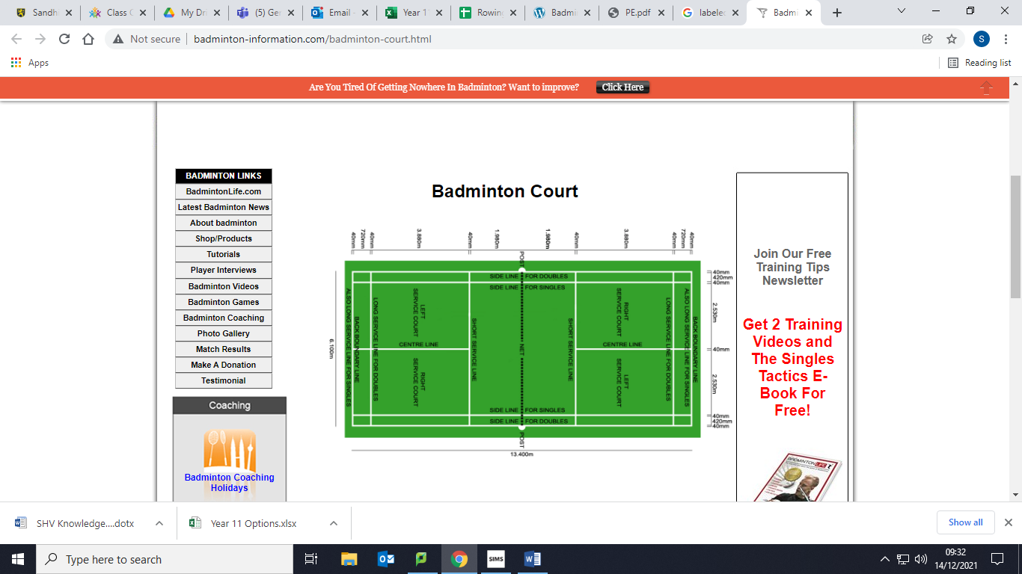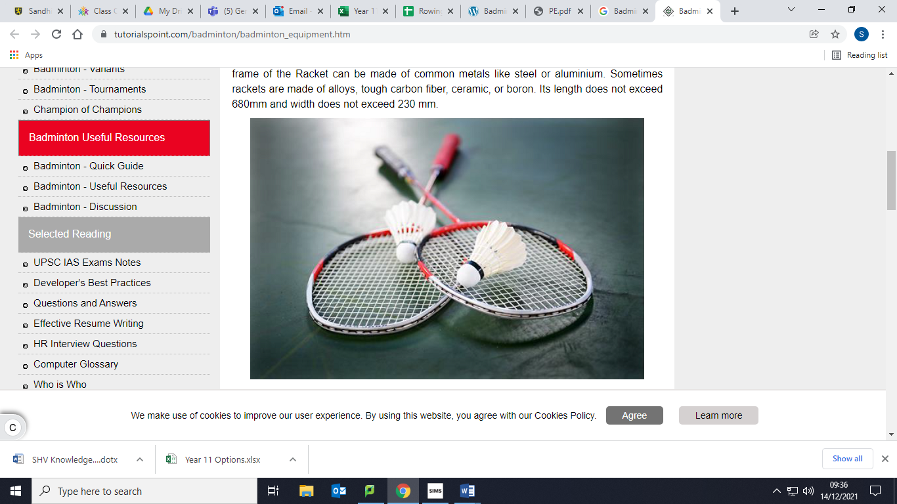

**Year 7 Badminton**

**P.E**