**Fossils**

Could be:

1. The actual remains of an organism that has not decayed
2. Mineralised forms of the harder parts of an organism such as bones
3. Traces of organisms such as footprints or burrows

**Resistant Bacteria**

1. There is a variation in the bacterial population. One bacterium develops a mutation by change that means it is resistant to an antibiotic.
2. The antibiotic kills some of the bacterial, the resistant bacterium survives and reproduces.
3. The antibiotic kills the rest of the non-resistant bacteria so the person may start to feel better but the resistant bacterium survives and continues to multiply.

To reduce the rate of this: antibiotics should only be used when necessary, patients should complete their full course, agricultural use should be restricted.

**Genetic engineering**

Using in crops and to make insulin. DNA is removed from human cell and plasmid is isolated from a bacterial cell. Gene required is removed from the human DNA by enzymes, plasmid is cut using enzymes. Gene is inserted into the plasmid. Plasmid (vector) is used to insert the gene into the required cell. Bacteria multiply many times.

**Selective Breeding**

Scientists choose parents who have the desired characteristics and breed them. Then select the offspring with the best characteristics and breed them again. This continues over many generations until the desired results are achieved.

**Evolution**

All species of living things have evolved from simple life forms by natural selection. If a characteristic is advantageous in an environment then the individual will be better able to compete for resources, this means they are more likely to survive and reproduce, their offspring then inherit the advantageous allele.

**Mitosis and Meiosis**

Mitosis: Produces 2 daughter cells which are genetically identical, the cell divides only once, there are the same number of chromosomes (46) in each daughter cell, used for growth and repair and in asexual reproduction.

Meiosis: Produces four daughter cells which are not genetically identical, the cell divides twice, chromosome number is halved (23) produces gametes for sexual reproduction.

**Variation**

Genetic – variation in DNA.

Environmental – conditions in which they have developed

Combination of both.

**Punnet Squares**

To complete a punnet square you must put the two alleles from the parents on the top and on the left. Then you must copy these alleles down and across to fill in the squares.

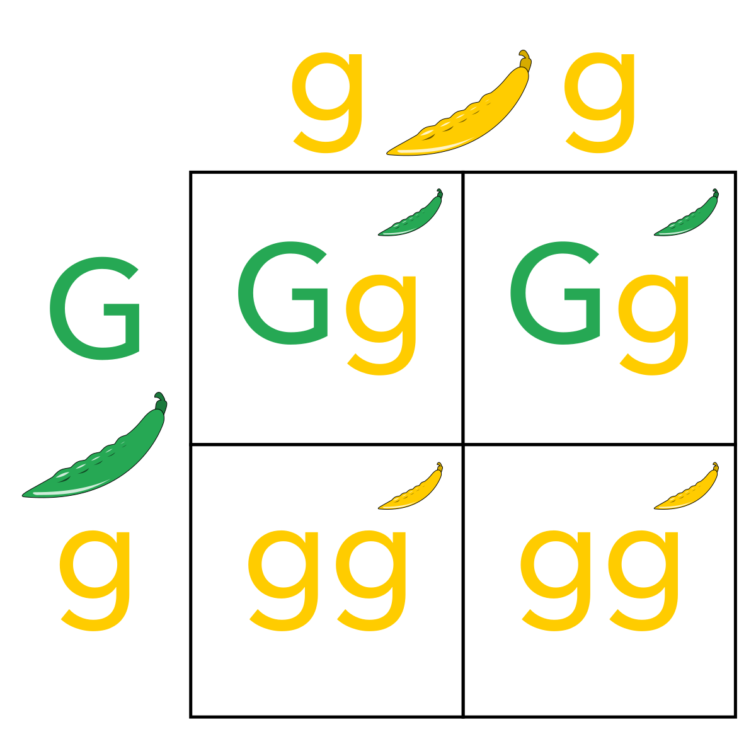

The probability is calculated out of 4 potential offspring.

**Keywords**

**Allele** – alternative forms of a gene (e.g blue eyes, brown eyes)

**Asexual reproduction** – cloned offspring produced by a single parent.

**Dominant** – an allele that is always expressed, even if only one copy is present.

**Gamete** – sex cells

**Gene** – small section of DNA that codes for a specific trait.

**Genome** – the entire genetic material of an organism

**Genotype** – the combination of alleles in an organism

**Heterozygous** – a genotype that has two different alleles

**Homozygous** – a genotype that has two of the same alleles

**Recessive** – an allele that is only expressed if two copies are present.

**Classification**

Linnaeus classified living things into:

Kingdom

Phylum

Class

Order

Family

Genus  
Species

Due to evidence from chemical analysis, there is now a three-domain system developed by Carl Woese.

The three domains are:

Bacteria

Archaea

Eukaryota

**DNA**

DNA is a polymer that makes you, you. Small sections of this DNA are known as genes and they code for characteristics in an organism. Longer, coiled chains of DNA are known as chromosomes, these are found in the nuclei of cells. Humans have 23 pairs (46) chromosomes.

**Ambitious Vocabulary**

Variation Chromosome Selective Evolution

**Year 11 B6 Inheritance and Variation**

**Science**

**Understanding of genetics**

**1856** – Mendel begins his research.

**1866** – Mendel published the results, identifying unit of inheritance, his work goes unnoticed by other scientists.

**1882** - The chromosome ‘dance’ of mitosis was observed by Flemming.

**1884** - Mendel dies

**1900** – Boveri provides the first evidence that chromosomes are inherited.

**1902** – Chromosomes are observed separating into gametes during meiosis.

**1953** – the structure of the double helix was discovered

**Protein synthesis**

Inside the nucleus is the DNA – this is a template. The template is copied from the DNA and moves out of the nucleus. It binds to a ribosome. A carrier molecule binds to every three bases. Each one carries an amino acid which is joined to the previous amino acid. The amino acid strand folds into a 3D shape.

**Fungi**

Many fungi reproduce asexually by spores but also reproduce sexually to give variation.

**Malaria**

Malarial parasites reproduce asexually in the human host but sexually in the mosquito

**Speciation**

Parts of a population become geographically or environmentally isolated from each other, if the conditions in each environment are different then different characteristics will be advantageous. This leads to natural selection. Eventually the two separated populations are so different they can no longer interbreed to produce fertile offspring.

**Natural selection**

An organism with a favourable characteristic that suits its environment will more likely survive and therefore reproduce passing on its DNA to its offspring.

Darwin’s theory was only gradually accepted as:

The theory challenged the idea that God made all the animals and plants that live on the Earth

There was insufficient evidence at the time the theory was published to convince many scientists

The mechanism of inheritance and variation was now known until 50 ears after the theory was published.

**Cloning in plants and animals**

We take cuttings of plants and can culture this tissue through asexual reproduction (mitosis) to then create more of the same plant. Many plants produce seeds but also reproduce asexually by runners such as strawberry plants, or bulb division such as daffodils.

In animals the desired DNA is taken from a specific organism and implanted into an egg cell. This is then cloned as it becomes an embryo.

**DNA structure**

DNA is made of base pairs attached to a sugar phosphate backbone. These sections are called nucleotides. All together this structure is known as the double helix.

**Sexual and asexual reproduction**

Advantages of sexual reproduction:

Produces variation in the offspring, if the environment changes then variation can give a survival advantage via natural selection, natural selection can be increased by humans in selective breeding to increase food production.

Advantages of asexual reproduction:

Only on parent needed, more time and energy efficient as they do not need to find a mate, faster than sexual reproduction, many identical offspring can be produced when conditions are favourable.

**Ambitious Vocabulary**

Variation Chromosome Selective Evolution

**DNA**

DNA is a polymer that makes you, you. Small sections of this DNA are known as genes and they code for characteristics in an organism. Longer, coiled chains of DNA are known as chromosomes, these are found in the nuclei of cells. Humans have 23 pairs (46) chromosomes.

**B6 Inheritance and Response**

**Science**