**Pressure in Gases**

Particles in a gas move randomly and quickly. When they collide with a surface there is a force produced. The more collisions there are, the higher the total force produced.

To increase the pressure of a gas particles either need more energy (to therefore move faster), or the container that particles are held in.

When the temperature of a gas is increased, the particles gain kinetic energy and therefore move faster. This means there are more collisions per second and more force produced.

**Particles**

**Solids** – regular arrangement, particles close together in fixed position, strong forces, low energy and can only vibrate.

**Liquids** – irregular arrangement, close together, free to move, weaker forces, more energy.

**Gases** – irregular arrangement, particles separate, very weak forces, lots of energy, move randomly.

**Diffusion**

When a substance moves from an area of high concentration to low concentration until the particles are evenly spread. Examples of diffusion in the body are: oxygen and carbon dioxide entering and exiting red blood cells.

**Melting and Boiling Points**

**Heating graph:**

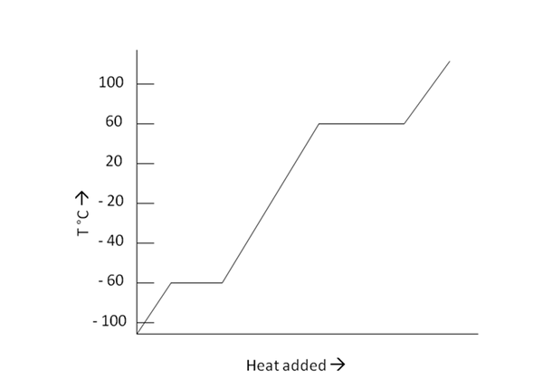When a substance is heated continuously the temperature can be measured throughout. Assuming the substance is a solid, the heating curve above can be drawn. When the temperature is increasing, the kinetic energy of the particles is increasing causing the substance to heat up. When the substance reaches its melting point the temperature stops rising and instead stays constant. During this time, the particles spread out and the substance becomes a liquid. After this, the temperature rises again, heating the liquid, and increasing the speed of the particles.

When the substance reaches its boiling point, again, the temperature remains constant. The particles spread out once again and the substance becomes a gas.

**Key Vocabulary**

**Diffusion**

The movement of particles from an area of high concentration to an area of low concentration until the particles are evenly spread

**Boiling**

Changing from a liquid to a gas (requires heating)

**Evaporating**

Changing from a liquid to a gas (does not require heating)

**Condensing**

Changing from a gas to a liquid

**Freezing**

Changing from a liquid to a solid

**Melting**

Changing from a solid to a liquid

**Sublimation**

Changing from a solid to a gas

**Changing State**

The process of changing between a solid and a liquid is melting (solid to liquid) or freezing (liquid to solid). The process of changing between a liquid and a gas is evaporating, boiling (liquid to gas), or condensing (gas to liquid). When a substance changes state there is no chemical change, only physical. No new substance is formed and the substance can return to its original state. The number of particles remains the same and the mass is conserved.

**Three States of Matter**

The three states of matter are solids, liquids, and gases. All matter is made up of particles.

**Ambitious Vocabulary**

Conserved Kinetic Diffusion State

**Y7 Particle Model**

**Science**