|  |  |
| --- | --- |
| **Tattooing** | A tattoo is a form of body modification where a design is made by inserting ink, dyes and pigments, into the skin |
| **Theme** | **In art**, **theme** is usually about life, society or human nature, but can be any other subject. **Themes** are the ideas explored **in** a work. |
| **Emotion** | a strong feeling such as joy, hatred, sorrow, or fear. When one feels an emotion, there are physical changes such as an increase in pulse, crying, or trembling. |
| **Message** | What is the artwork about? What does it mean? The message of an artwork is what you take away from looking at it. |
| **The Grid Method** | **The grid method** is a way to reproduce and/or enlarge an image that you want to paint or draw. **The grid method** involves drawing **a grid** over your photo, and then drawing **a grid** of equal ratio on your piece of paper. |
| **Ramon Maiden** | A self-taught tattoo artist from Barcelona. |

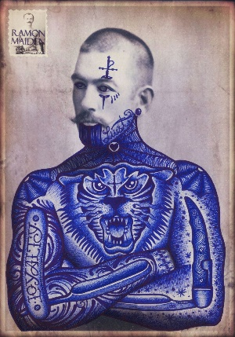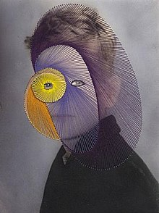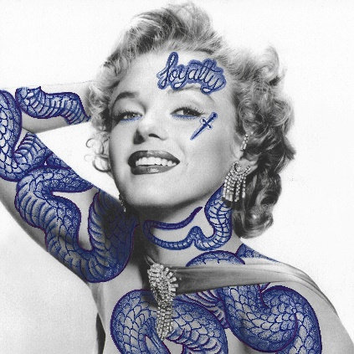

**Explore Identity Art in a variety of materials: pencil, pen, watercolour, coloured pencils, oil pastels, felt pens.**

**You can copy work from the artists Ramon Maiden and Maurizio Anzeri**

**Try creating your own blue biro pen tattooed portrait. Could you represent yourself through the tattoo symbols and stitching?**

Non-examples

Examples

Characteristics

Definition

Identity

**Year 9 Protest Art**

**Art and Design**