|  |  |
| --- | --- |
| **Pop Art​** | art based on modern popular culture and the mass media, especially as a critical or ironic comment on traditional fine art values.**​** |
| **Theme**​ | **In art**, **theme** is usually about life, society or human nature, but can be any other subject. **Themes** are the ideas explored **in** a work.​ |
| **Ben-Day dots**​ | The Ben Day process, named after illustrator and printer Benjamin Henry Day Jr. is a printing and photoengraving technique dating from 1879.​ |
| **Roy Lichtenstein**​ | an American pop artist. During the 1960s​ |
| **Andy Warhol**​ | an American pop artist. During the 1960s​ |
| **Primary Colours**​ | A **primary color** is a **colour** that cannot be made from a combination of any other **colours**. (Red, Yellow and Blue)​ |
| **Secondary Colours**​ | A secondary **colour** is a **colour** created from a combination of two **primary colours. (Green, Purple, Orange)**​ |

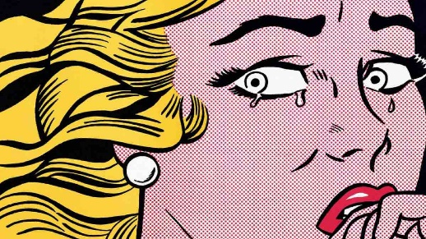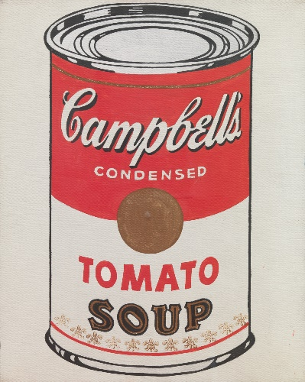

**Explore Pop Art in a variety of materials: pencil, pen, watercolour, coloured pencils, oil pastels, felt pens.**

**You can copy work from the artists Andy Warhol and Roy Lichtenstein**

**Try making your own Ben Day dot comic portrait or a Campbell’s Soup can.**

Non-examples

Examples

Characteristics

Definition

Pop Art

**Year 8 Pop Art Portraits**

**Art and Design**