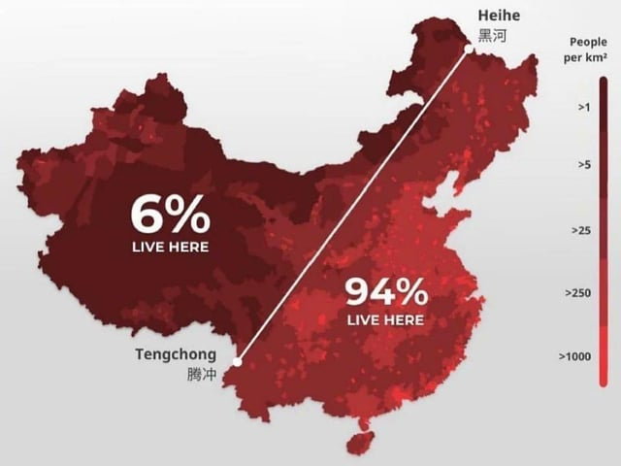

**China**

 Most people in China

live in the eastern half

of the country. This is

due to the regions rich

soil, moderate

temperatures and fresh

water which makes it

ideal for farming to

support the large population.

**Challenges and opportunities of living near a volcano**

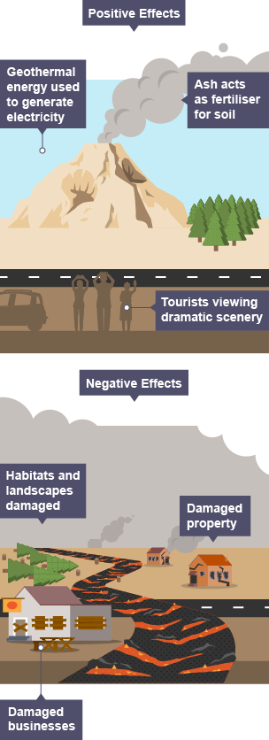

The **north south divide** is the term used to describe the social, economic and cultural disparities between London and the southeast of England and the rest of the England.

|  |  |  |
| --- | --- | --- |
|  | London | Newcastle |
| Average yearly income | £44,370 | £35,000 |
| Employment rate | 66% | 74.3% |
| Education level (maths and English GCSE at grade 9-4) | 71.2% | 40% |
| Child Poverty rate | 33% | 45% |
| English as a second language | 22% | 10.5% |
| Average house price | £521,000 | £218,961 |

**Physical features –** A feature on earths surface that has been created by natural. For example, upland areas (mountains), rivers and seas.

**Tectonic hazards-** Tectonic hazards threats caused by the movement of tectonic plates that have the potential to cause damage to life, property, the environment, human activity and/or the economy

**Superpower –** A superpower is a country with the ability to project its power and influence around the world.

**Natural Resources in Russia:**

* Energy (Russia has the world’s largest reserves of natural gas reserves and is a major producer and exporter of oil. The Russian government’s budget is largely dependant on revenues from oil and natural gas sales).
* Minerals (important for economic development as it is closely tied to its mineral resources and the prices of the raw materials. Russia’s mineral industry is one of the world’s leading mineral industries)

**Oil in Saudi Arabia**

Oil is Saudi Arabia accounts for 90% of their budget and it is one of their main exports. They export it to countries such as China, Japan and South Korea. Having control over large amounts of oil has allowed Saudi Arabia to gain significant influence in global energy markets and international politics.

The wealth from the oil industry has allowed for significant investment in infrastructure, healthcare and education.

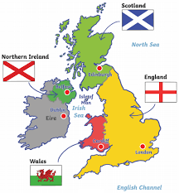

**Year 7 People and Places**

**Geography**