**Key Skills –**

Head up frontcrawl

Dribbling skills – not touching the ball, ensuring ball kept within your space

Passing skills – everything one handed

Shooting skills – dry pass, wet pass

Dry pass- A dry pass is a pass between two players over water, where the ball does not touch the water at all.

Wet pass -Wet passes, as its name suggests, means that the ball touches the water. This is done when a player throws the ball so that the ball lands in the water near to the teammate.

**Tactics-**

The game consists of four quarters in which the teams attempt to score goals by throwing the ball into the opposing team's goal. The team with the most goals at the end of the game wins the match

At the start of the game all players against the wall and swim to centre for possession. After a goal, all players return to their own half and a pass back from centre to restart the game.

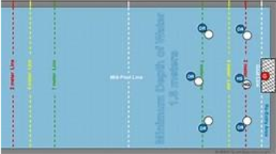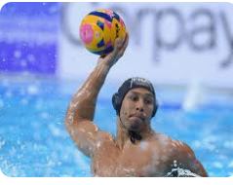

**Rules-**

7 aside- 4 x 8-minute quarters

One handed pass only

The ball cannot be submerged

Players can not move holding the ball

Players can not touch the bottom or side of the pool

Types of water polo foul

1. Ordinary Foul. Also called minor fouls, these are punished by the reward of an immediate free throw to the other team. Ordinary fouls are very common in water polo.

2. Personal Foul. There are two types of personal fouls. These are exclusion fouls and penalty fouls. Once a player has committed three personal fouls during a game, they must be substituted out of the match and cannot return.

3. Exclusion Foul. Exclusion fouls are also known as major fouls and, unsurprisingly, are for more serious breaches of play than minor fouls. They result in a free throw to the opponents, and the exclusion of the fouler for 20 seconds.

4. Penalty Foul. Penalty fouls are usually awarded when a major foul is committed within 5m of the goal, or when a clear opportunity to score is denied by a foul. These result in a penalty shot from the 5m line

**Year 9 Water polo**

**P.E**