Y9 Netball

PE

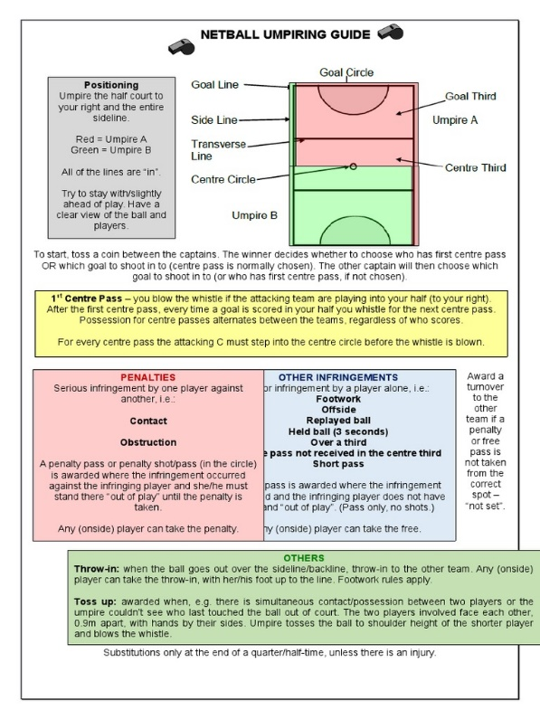

**Umpiring/Officiating**

A game of netball has two umpires. They have specific areas on the court to officiate in.

There are many rules or infringements they will penalise players for eg obstruction, contact, footwork, ball handling, over a third, off side, held ball, short passes, ball not received in the centre third.

Alongside these rules, they will use hand signals to identify them and a whistle to enforce them.

The game should run smoothly and quickly, no substitutes are allowed in netball unless there is an injury, or it is a scheduled break in play.

The team taking the centre pass alternates after each goal is scored.

If a free pass is given, then the player penalised is free to mark another. If a penalty pass is given, then the penalised player must stand by the side of the player taking the penalty pass.

**Key Words**Attack: Attack in netball involves players keeping possession and passing the ball across the centre and goal third to the shooting circle, also known as the D or semi-circle.

Defend: There are three stages of defending in netball; marking the opposing player, marking the ball and marking the zone. The aim of defending is to create an interception and become the attacking team.

Obstruction: You must stand one meter away from the opposition with the ball, otherwise you will be called by the umpire for obstruction and the opposition will receive a penalty pass. You will have to stand by their side, out of the game, until they play this pass.

Outwitting your opponent: to get an advantage over a player by using tactics.

Accuracy: To play precisely or correctly e.g. your passes must be timed accurately when passing into space.

Set Pieces/Tactics: Strategies adopted to increase the successful patterns of play from a dead ball starting point eg centre pass, sideline ball.

Footwork: When in position of the ball, you must not move the foot you landed on when you first received the ball. If you move your landing foot, the opposition will receive a free pass.

Umpiring: To be in charge of the game. There are normally two umpires in netball with their designated areas to officiate in.

**Set Pieces and Patterns of Play**

Centre pass strategies, side line passes and back line passes, all have the ability to gain your team some vital passages of play. If executed well, they help you outwit opponents andmaster your defending skills. 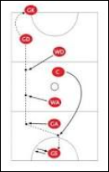

**Defending**

Marking is used to prevent your opponents from gaining an advantage. It can be man-to-man, sometimes zonal and also in the form of blocking. Tipping is also a good skill to have as it will enable you to intercept and if advanced tipping is achieved, you can touch the ball to players on your team.

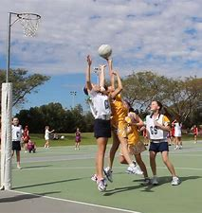

**Year 9 Netball**

**PE**