**Rules of Handball:**

* Each team has 7 players playing at one time. The positions are, goalkeeper, right and left back, center back, right and left wingers and a pivot.

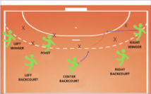

* A team cannot keep possession of the ball without attempting to attack.
* A player can take 3 steps before and after dribbling the ball, but cannot double dribble.
* A player will commit a foul if the reach out with their arms or legs to push, kick, punch, trip, hit or hold another player.

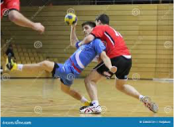

* Players can not pull, punch or hit the ball out of an attacker’s hands.
* After a small foul is committed, play restarts when the fouled team takes a free throw from where the foul was made.
* The ball must be passed with 1 hand, either hand is legal.

**Techniques used in handball:**

**3 types of passing:**

**Shoulder pass:** Used to cover longer distances. Players should use 1 hand to throw the ball from the shoulder. The trajectory of the ball should look like and arch.

**Hip pass:** A quick pass used to cover small distances quickly. Using one hand, players should throw the ball from their hip in a swimming action. The ball should be released before the throwing arm is pointing at target.

**Bounce pass:** This is a pass used to get around a defender. The player should use 1 hand and throw the ball downwards to allow the ball bounce once before reaching its target. The player should look to bounce the ball at 75% of the way towards their target.

**Dribbling:** Dribbling is used to get past a defending player. The ball should be bounced by using one hand and by using the fingertips of that hand. The ball should be bounced at hip height to maintain good ball control. The player dribbling can have 3 steps before and after bouncing the ball.

**Jump Shot:** The jump shot is used to score goals. The team with the most goals at the end of a game wins. To score, player should approach the shot line and jumping up and over the line. The player must release the ball before landing inside the box. To shot, players should use their dominant hand and throw from the shoulder. Players should be accurate by aiming in between the goal keeper and the goal posts.

**Year 9 Handball**

**PE**