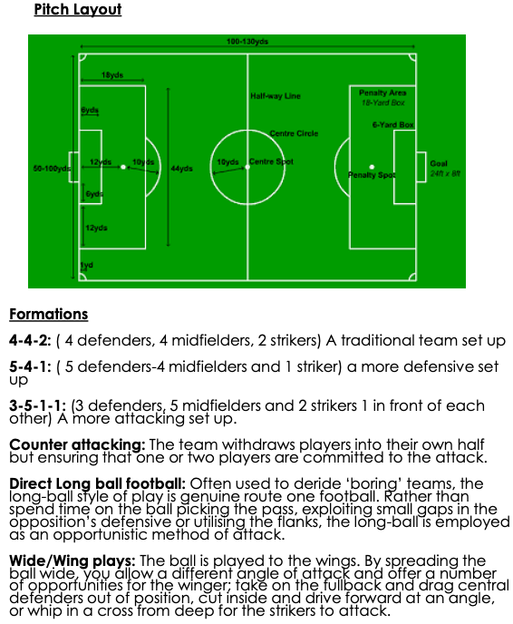

**Man Marking Defending**

Man marking defending is when each player on a team defends one particular player. For example, A CB will stay will the same ST all game.

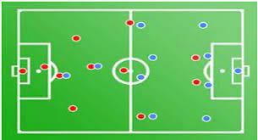

**Zonal Defending**

Zonal defending is when each player on a team defends a zone on the pitch. For example, all 4 defenders will defend enough area to cover across the pitch.

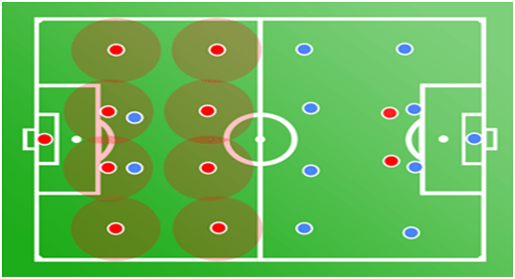

**Formations Pitch Layout**

**4-4-2** (4 defenders, 4

midfielders, 2 strikers) – A

traditional team set up.

**5-4-1** (5 defenders, 4

midfielders, 1 striker) – A

defensive set up.

**3-5-1-1** (3 defenders, 5

midfielders, 2 strikers) An

attacking set up.

**Counter Attacking:** The team withdraws players into their own half whilst ensuring that one or two players are committed to the attack.

**Direct Long Ball Football**: Often described as ‘boring’ teams, the long ball style of play is genuine route one football. Rather than spend time on the ball picking the pass, exploiting small gaps in the opposition’s defence or utilising the flanks, the long ball is employed as an opportunistic method of attack.

**Wide/Wing Play:** The ball is played to the wings. By spreading the ball wide you allow a different angle of attack and offer a number of opportunities for the winger; take on the fullback and drag central defenders out of position, cut inside and drive forward at an angle or whip in a cross from deep for the strikers to attack.

**Football**

**Year 9 PE**