**Rules of football:**

**Handball:** Handball is when a player makes an intentional contact with the ball with any part of their arm.

**Offside:** Offside is a rule invented to stop strikers poaching the goal. There must be at least 1 defender between the attacking player and the goalkeeper when the attacker is passed too.

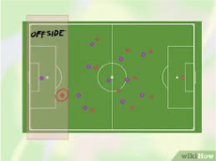

**Fouls:** A foul can be committed anywhere on the football field and will result in the offending team giving the ball away to the fouled team. Examples of fouls can be pushing, kicking a player while trying to tackle and tripping a player over.

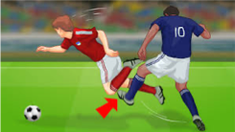

**Techniques used in football:**

**Long distance passing:** This type of pass is used to create more space and force the defending team to stretch their formation. Player should keep their non-kicking leg alongside the ball, the player should connect the top of their kicking leg foot to the ball, use their arms for balance and look towards the target.

**Ball control:** Players are required to receive the ball from other players on their team. To do this, players should place 1 foot behind the ball, soften the contact of the ball by angling the foot into a direction the ball can roll into. This can be done with either foot but players should try to use their strongest foot.

**Shooting:** Shooting is important in football because it gives the players a chance to score a goal. These are important because scoring is the only way to win a game. To do a finesse shot, players should use the inside of their foot to guide the ball into a specific area of the goal. Players should place their non-kicking foot alongside the ball, and use their kick foot to place the ball into 1 corner of the goal.

**Attacking as a team:** Football is a team sport and requires players to do a lot of movement without the ball. Part of this is knowing when to transition from defending into attacking. Once the defending team has won possession, they should look to move into their attacking positions but communicating their runs and following the team’s tactics.

**Year 8 Football**

**PE**