Topic Key Learning:

* Musical Element Keywords, Meanings & Uses
* Keyboard Layout, Notes & Left Hand Finger Positions
* Musical Notation Bass Clef
* Texture in Music

Keyboard Layout Reminder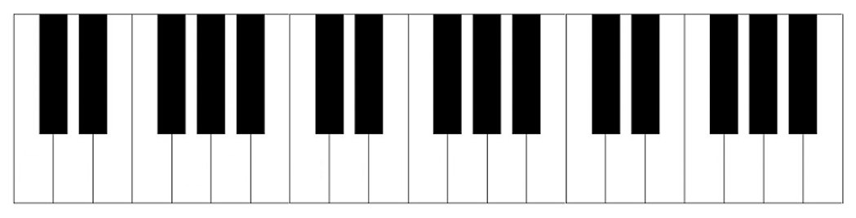

C D E F G A B C

Keywords & Terms

Pitch – How high or low a sound is

Rhythm – The patterns of music

Melody – The main tune

Dynamics – The loudness of music

Tempo – The speed of music

Tonality – The mood or emotion of music

Bass Clef – This appears at the start of written music and tells us the correct pitches to play – Left Hand Notes

Harmony – Playing 2 or more notes together

Timbre – The instruments used in music and their sounds

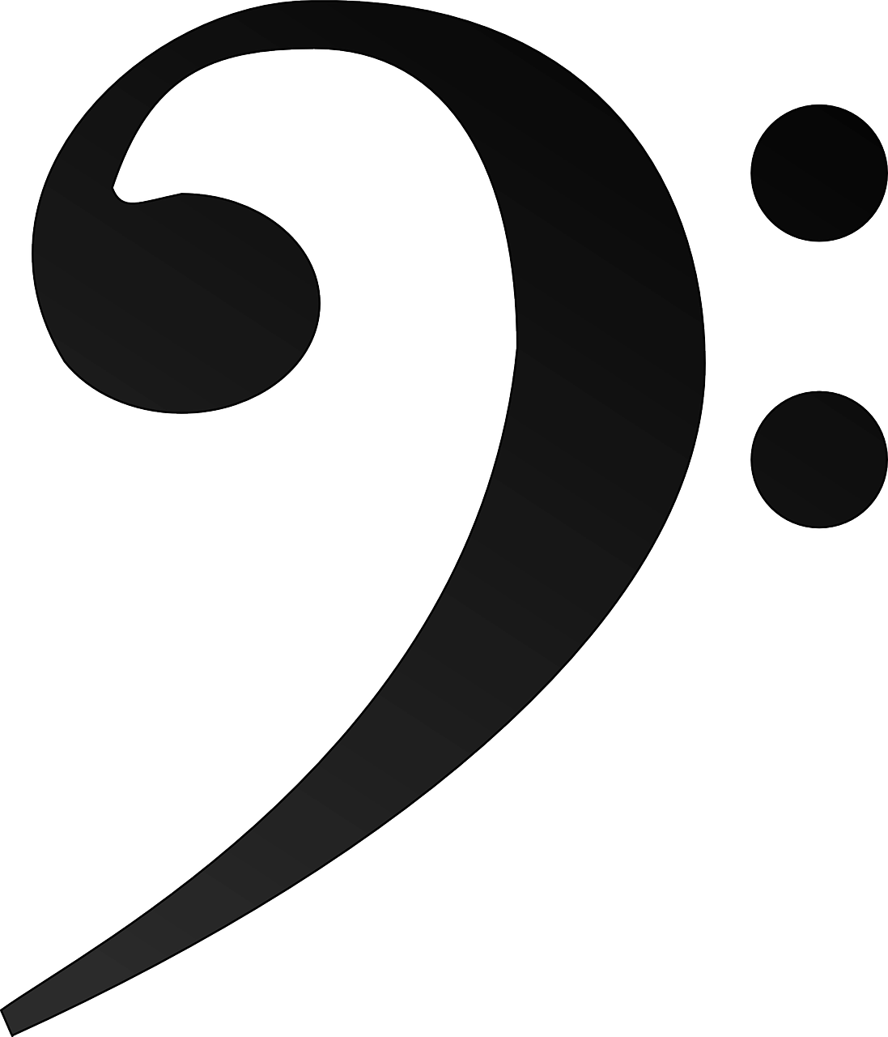

Musical Notes on the Bass Clef

Left Hand Finger Positions on Keyboards

4 Textures in Music  
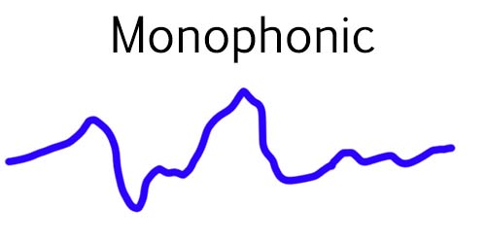

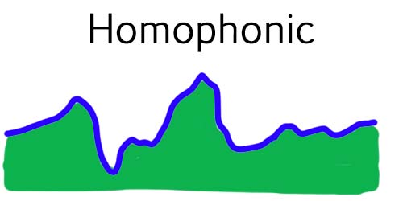

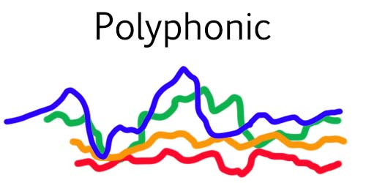

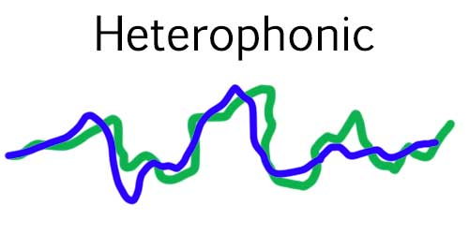

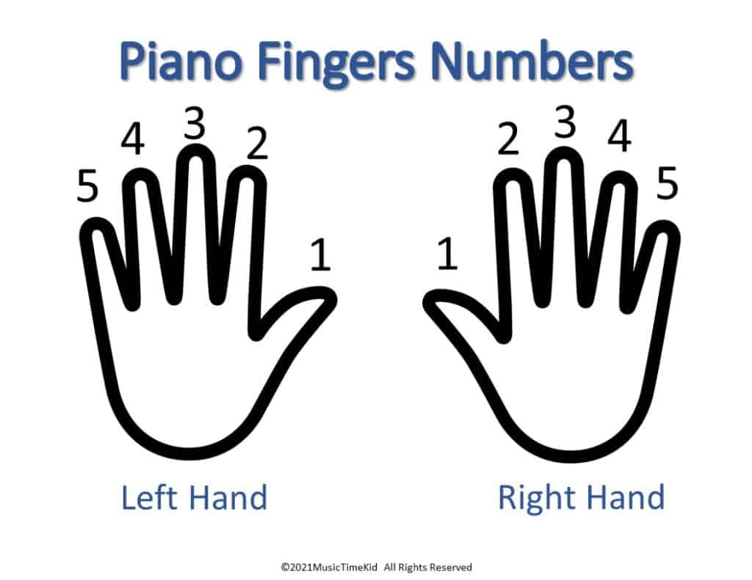

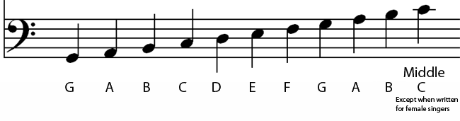

**Year 8 Exploring Elements**

**Music**