Y8 Netball

PE

**Shoulder Pass**

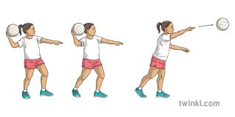

1. Control the ball with both hands, placing it above your shoulder, then remove the supporting hand.

2. Fingers should be spread behind the ball.

3. Feet should be should width apart.

4. Bring the ball back, bending your elbow.

5. Bring the arm forward, following the ball through until your arm and fingers are in front of you, in the direction you want the ball to travel.

6. As you bring your arm forward, step forward with the opposite foot to the arm you are holding the ball in,

**Rules**

Contact: You cannot touch or push any player during the game. This will result in a penalty pass, or penalty shot if you are in the circle, to the opposition.

Footwork: If the player moves their landing foot or takes steps with the ball, the opposition get a free pass.

Obstruction: You must be at least 1 metre away from the player from the opposite team with the ball before you mark or defend the ball. This will result in a penalty pass, or penalty shot if you are in the circle, to the opposition.

Held Ball: You can only hold the ball for 3 seconds before you pass or shoot.

Repossession: If a player drops the ball, or bounces the ball, and picks it back up again, the opposition get a free pass.

**Shooting**

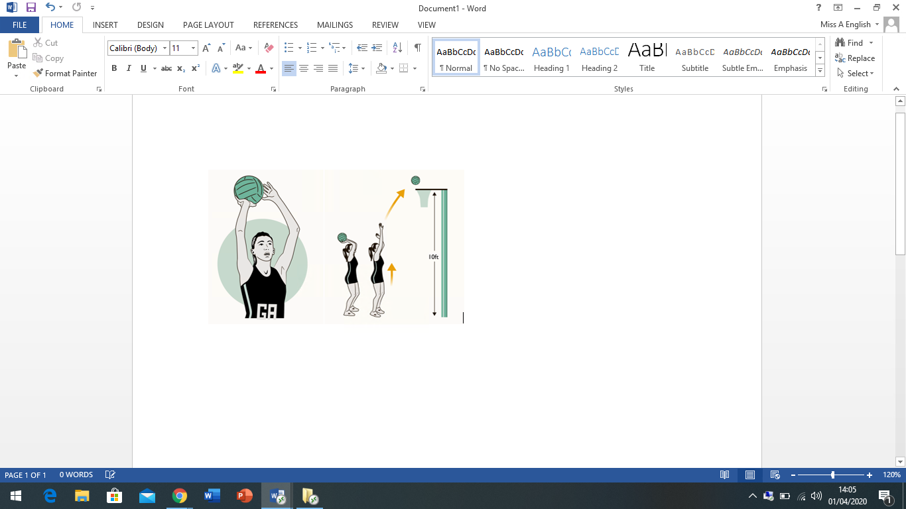

1. Rest the ball on your preferred shooting hand with the other hand supporting on the side.

2. Feet should be shoulder width apart.

3. Look at the back of the ring.

4. Bend your knees, lift your heels off the floor and push the ball up and over the top of the ring to loop into the net.

**Chest Pass**

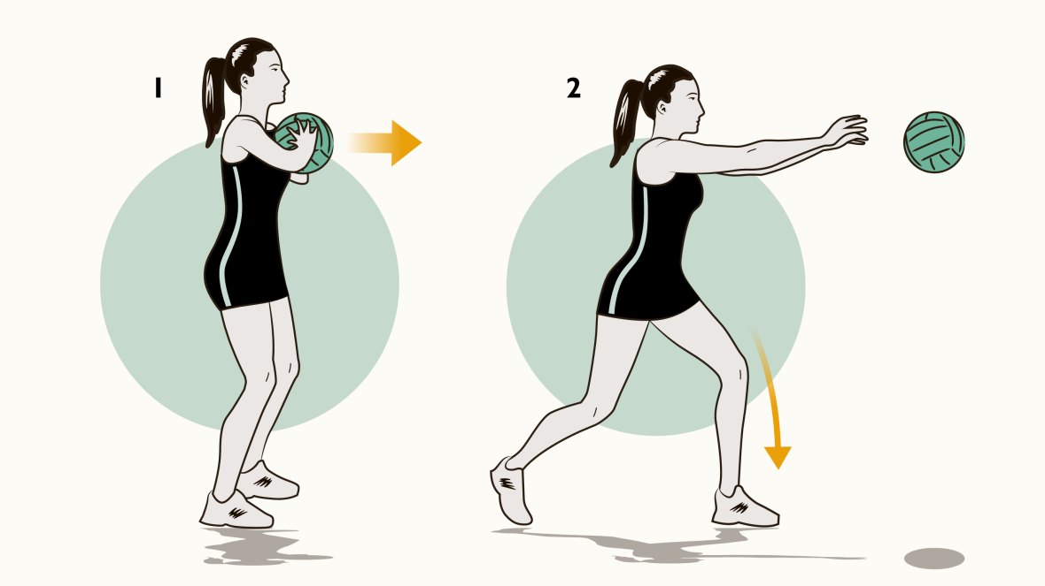

1. Thumbs and index fingers form a W shape. The remaining fingers should be spread behind the ball to push it away.

2. Elbows should be kept low and close to the body. Feet should be shoulder width apart.

3. Keep the ball close to your chest.

4. Fingers facing forward, push the ball towards to the chest of the receiver to create a flat, strong pass.

5. As you push the ball forward, step forward with one foot.

**Key Words**Attack: Attack in netball involves players keeping possession and passing the ball across the centre and goal third to the shooting circle, also known as the D or semi-circle.

Defend: There are three stages of defending in netball; marking the opposing player, marking the ball and marking the zone. The aim of defending is to create an interception and become the attacking team.

Chest pass: This pass is used when the receiving player is close in distance to the person throwing the ball. It travels from one player’s chest straight to the other player’s chest.

Shoulder pass: This pass is used when the receiving player is further away in distance to the person throwing the ball.

Shooting: This is how points are scored in netball. Only the Goal Attack or Goal Shooter can shoot when they are in the semi-circle.

Dodging: Dodging in netball terms relates to moving from side to side to confuse the opponent before sprinting off to catch the ball.

Footwork: When in position of the ball, you must not move the foot you landed on when you first received the ball.

GS – to score goals and to work in and around the circle with the GA.

GA – to feed and work with the GS and to score goals.

WA – To feed the circle players, giving them opportunities to shoot.

C – To take the centre pass, and to link the defence and the attack.

WD – To look for interceptions and prevent the opposition’s WA from feeding the circle.

GD – To win the ball to get the ball out of the danger area and reduce the effectiveness of the opposition’s GA.

GK – To work with the GD and to prevent the opposition’s GA/GS from scoring goals.

**Positions**

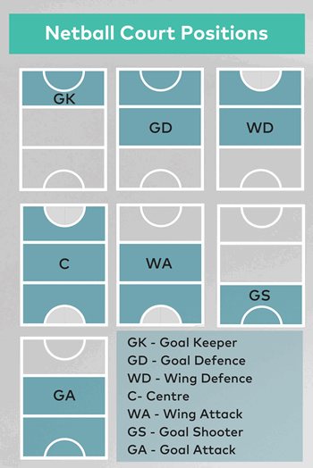

**Year 8 Netball**

**PE**