Loudest

Most Quiet

Dynamic Symbols

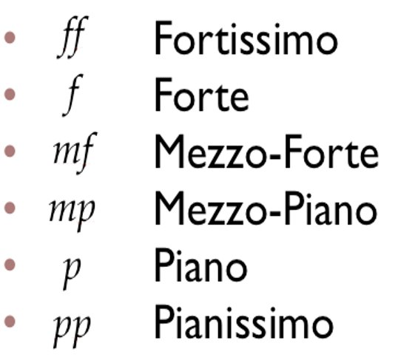

Topic Key Learning:

* Musical Element Keywords, Meanings & Uses
* Keyboard Layout, Notes & Finger Positions
* Musical Notation Notes & Symbols

Right Hand Finger Positions on Keyboards

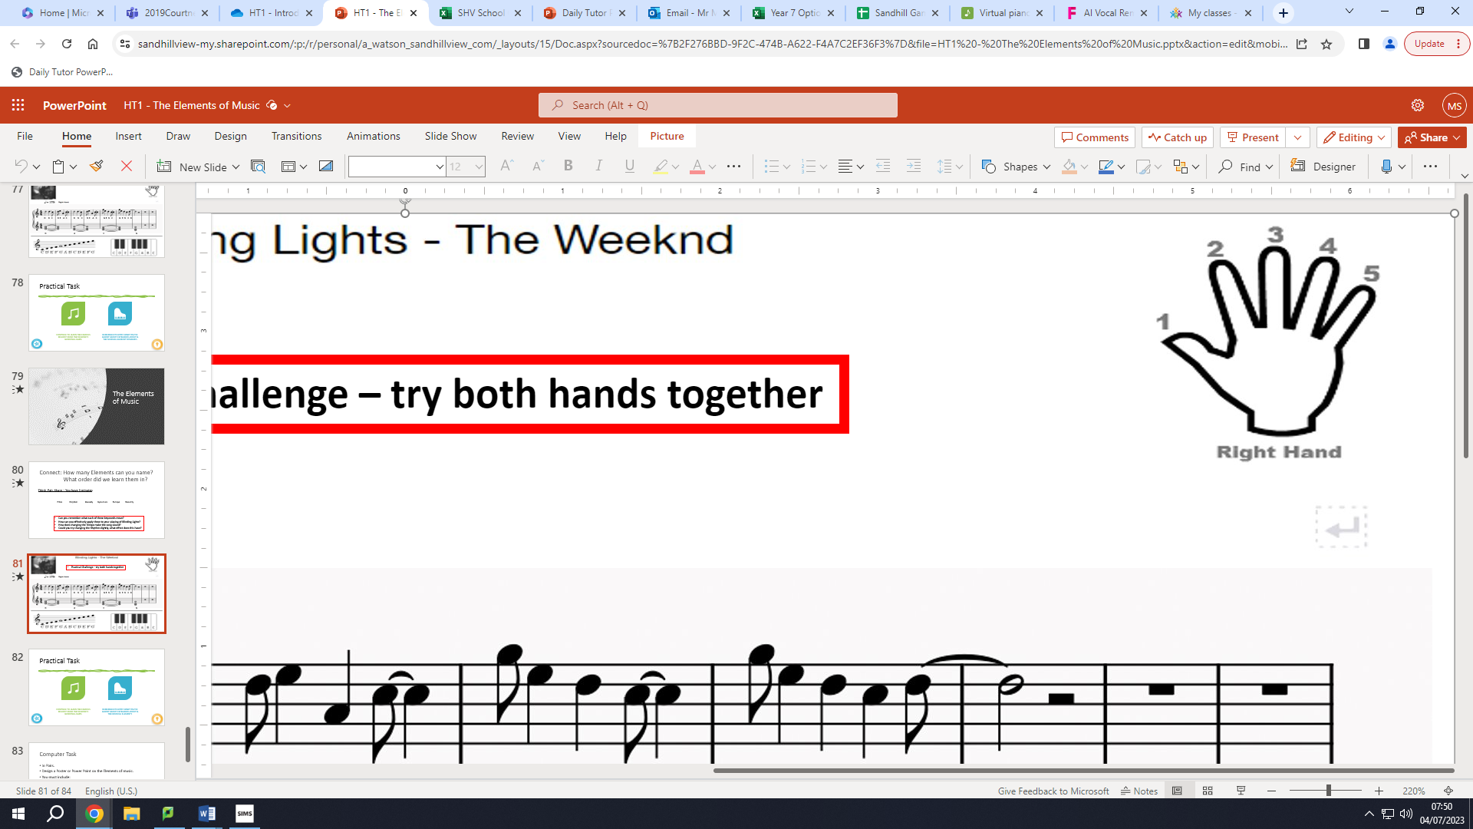

C D E F G A B C

Keyboard Layout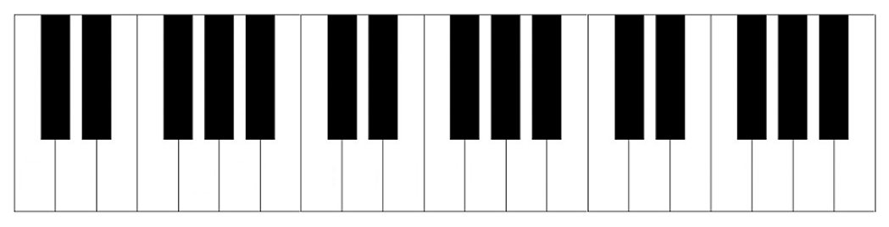

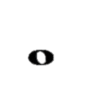  
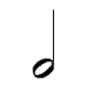  
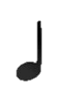  
 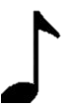

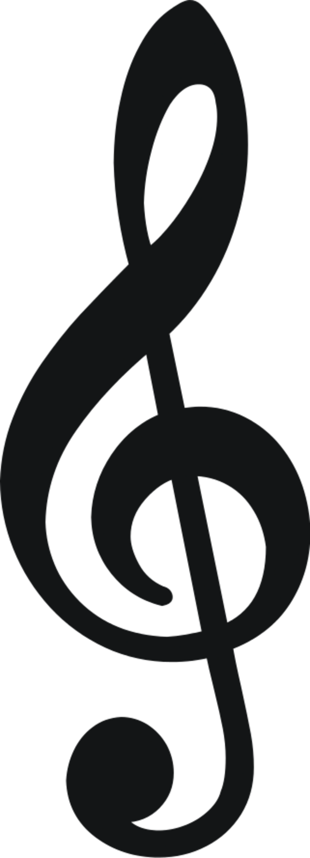

Musical Notes on the Treble Clef

Keywords & Terms

Pitch – How high or low a sound is

Rhythm – The patterns of music

Melody – The main tune

Dynamics – The loudness of music

Tempo – The speed of music

Tonality – The mood or emotion of music

Treble Clef – This appears at the start of written music and tells us the correct pitches to play – Right Hand Notes

Semibreve – A musical note worth 4 beats

Minim – A musical note worth 2 beats

Crotchet – A musical note worth 1 beat

Quaver – A musical note worth half a beat

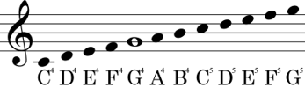

**Year 7 Musical Elements**

**Music**