**Strokes are broken down into –**

**B- Body Position**

**L- Leg Kick**

1. **Arm Action**
2. **Breathing**

**T- Timing**

**Types of Swimming strokes**

**Front crawl-** Face in, bilateral breathing, flutter kick, over arm recovery

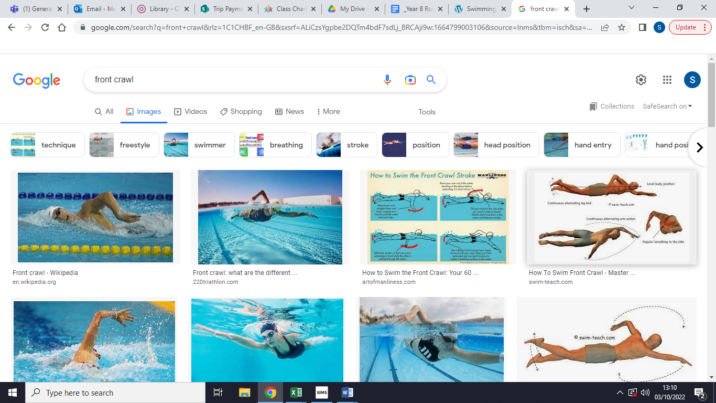

**Backcrawl-** – Head back, long legs, over arm recovery

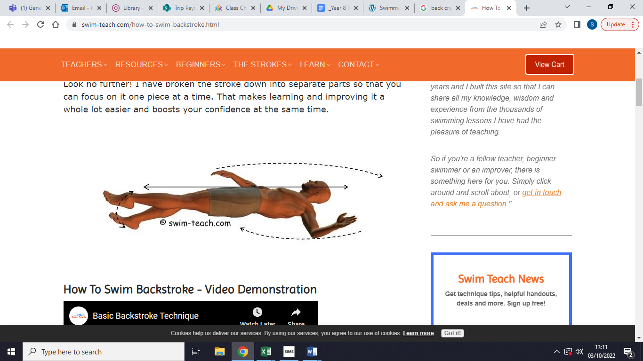

**Breaststroke-** Arms pull around and forward, legs kick out and around, breathing to the front

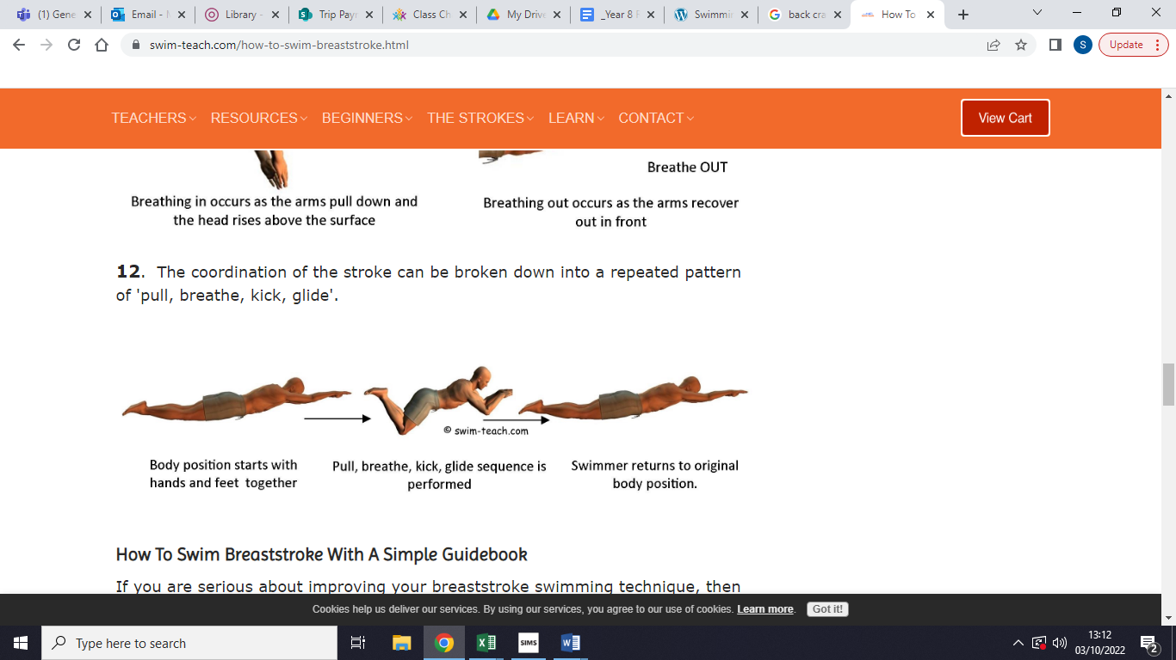

**Butterfly-** – Dolphin kick, undulating action from head, arms working simultaneously, breathing to front after every arm pull

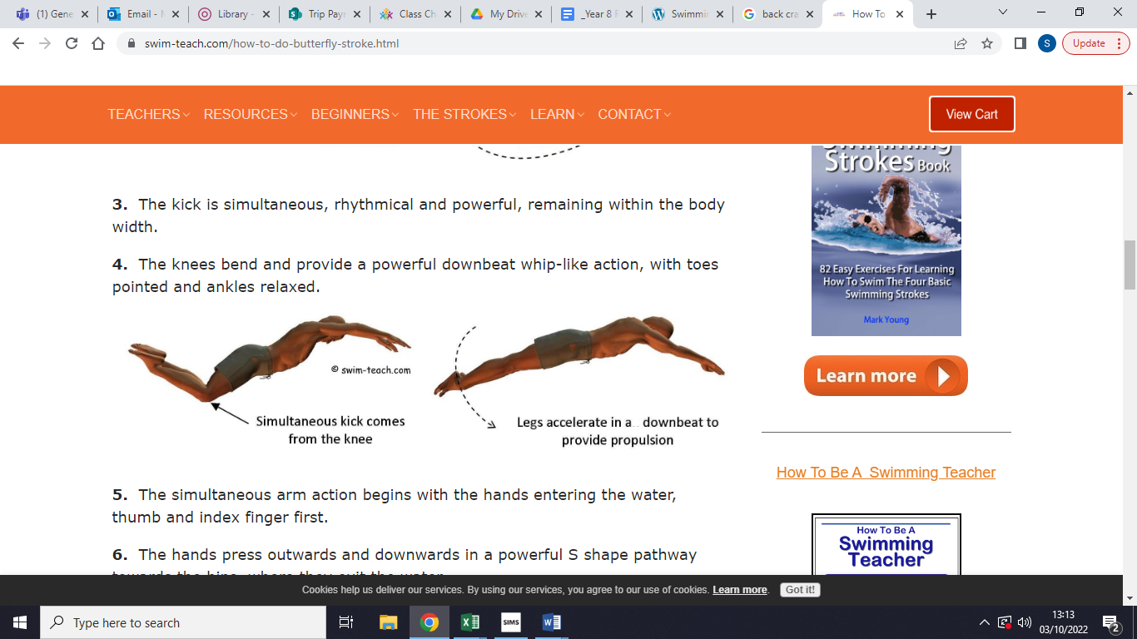

**Swimming skills**

**Floating -** supine & prone

**Push & Gliding -** front & back arms extended

**Sculling –** head first & feet first

**Surface dives -** head first & feet first

**Treading Water -** arms sculling, breaststroke legs

**Straddle Jump-** The purpose of a straddle jump is to not get your head wet

**Keywords –**

**Supine**

**Prone**

**Alternate**

**Simultaneous**

**Year 7 Swimming**

**PE**