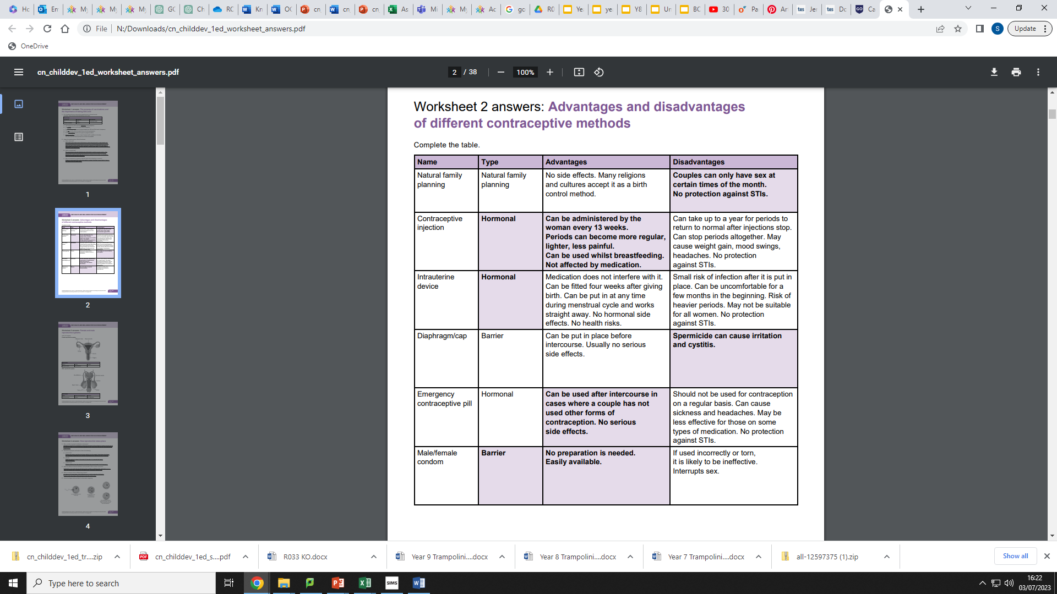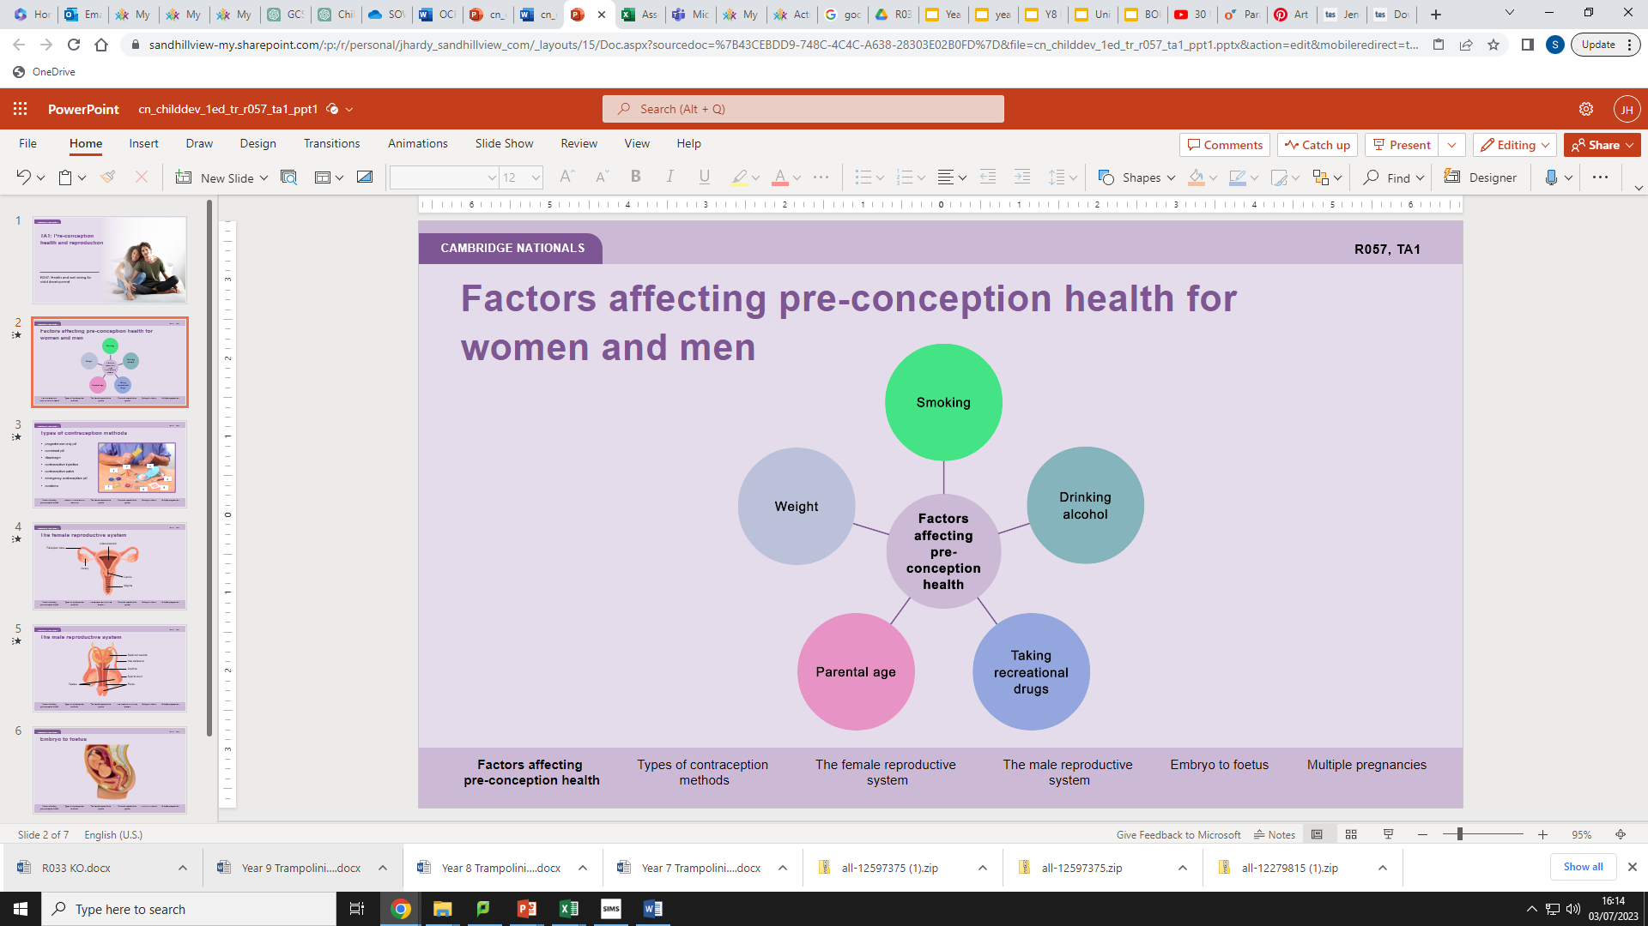

**RO57**

**Child Development**

**Contraception**

**Factors affecting preconception health**

**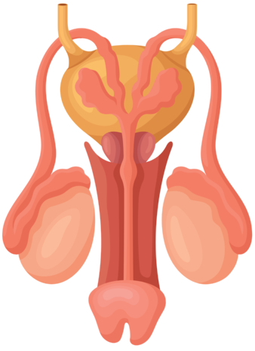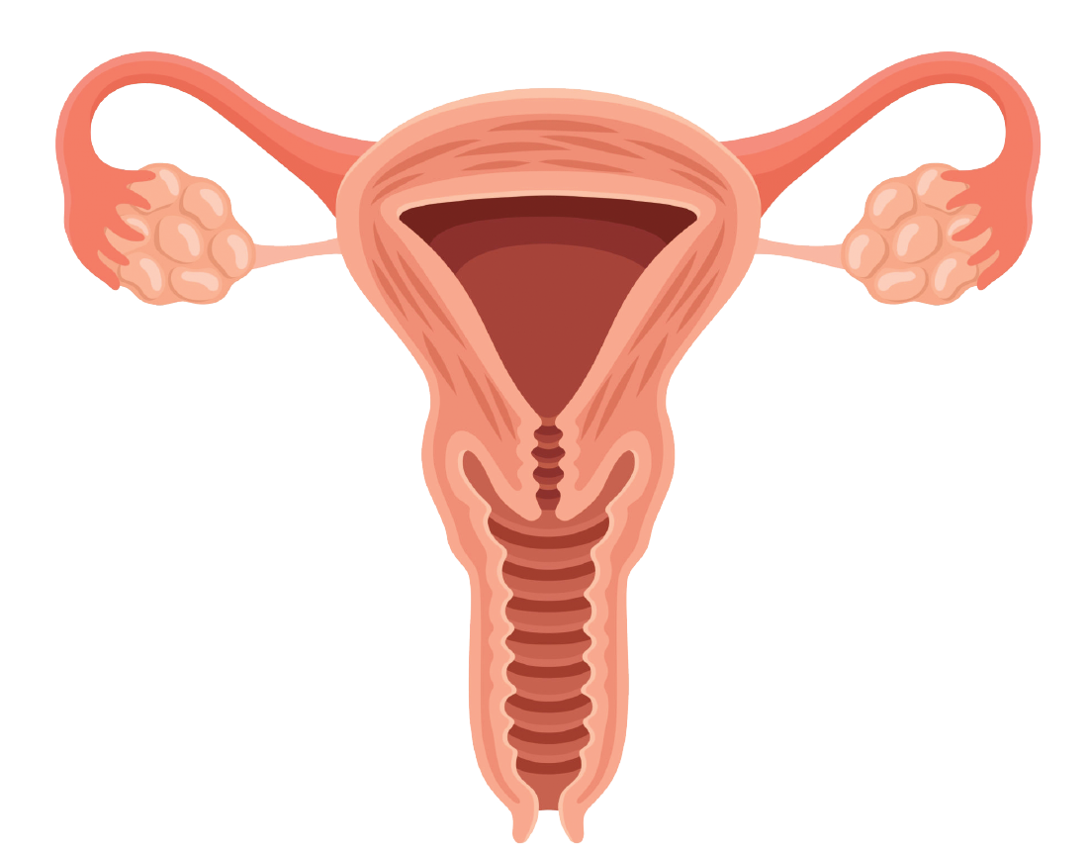

**Child Development**

Testes

**Male reproductive system**

Sperm duct

Urethra

Penis

Vas deferens

Seminal vesicle

**Female reproductive system**

Vagina

Cervix

Ovary

Fallopian tube

Uterus/womb

**Child Development**

**RO57**

|  |  |  |
| --- | --- | --- |
| **Screening tests** | **When carried out** | **Why carried out** |
| Ultrasound scans (sonograms)  offered to all women | Dating scan: 10–14 weeks  Anomaly scan: 18–21 weeks | Dating: to check delivery date  and for multiple pregnancies  Anomaly: to check for 11  rare conditions |
| Nuchal fold translucency scan offered to all women | 11–14 weeks | To help screen for Down’s syndrome |
| Triple test | Any time after 14 weeks | Offered to women who have not had an earlier scan |
| Non-invasive Prenatal Testing (NIPT) (not offered through NHS) | Any time after 10 weeks | To check for the risk of  Down’s syndrome |

* 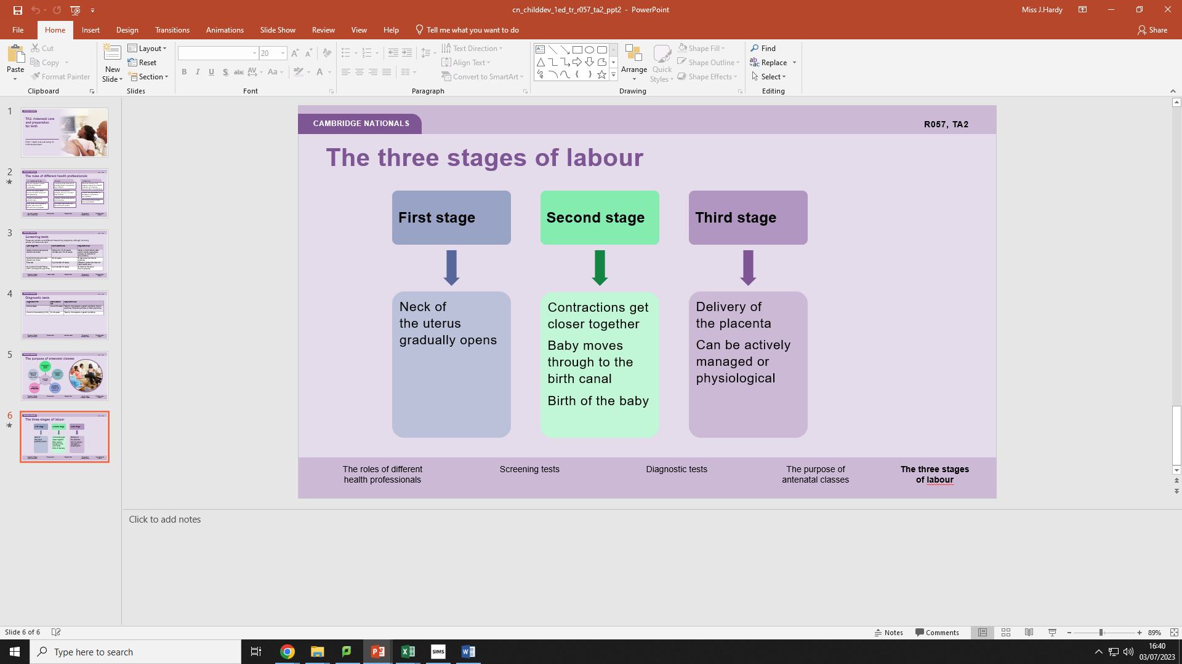

**Signs of labour**

**Antenatal classes**

* + Breastfeeding/feeding advice
  + To promote a healthy lifestyle
  + To prepare both parents for labour and parenthood
  + To provide advice/support on baby care
  + To promote a healthy diet, including foods to avoid

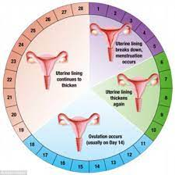

A doctor who specialises in   
all aspects of pregnancy   
and childbirth.

Not usually involved unless there are problems.

Becomes involved if the pregnant woman has a health condition or if there are concerns about the pregnancy.

**3** **Obstetrician**

Runs parenting classes and discusses birth options.

Provides clinical examinations and screening.

Provides antenatal and postnatal care up to a month after the birth.

A medical professional who is specially trained in pregnancy and childbirth.

**2** **Midwife**

Likely to be the first person a woman sees when she discovers she is pregnant.

Provides antenatal and postnatal care.

Will ask the woman about   
her mental health during and   
after pregnancy.

Can refer pregnant woman   
to other professionals,   
if necessary.

**1 GP (General practitioner)**

**3** **Obstetrician**

Not usually involved unless there are problems.

Becomes involved if the pregnant woman has a health condition or if there are concerns about the pregnancy.

A doctor who specialises in   
all aspects of pregnancy   
and childbirth.

**Menstrual Cycle -** This is the cycle when women have periods and are fertile. Girls begin their periods at the approximate age of 12 and finish approximately 51 during menopause.​ Women experience different types of periods and last between 3 and 7 days. Usually around 5.