**RO58**

**Child Development**

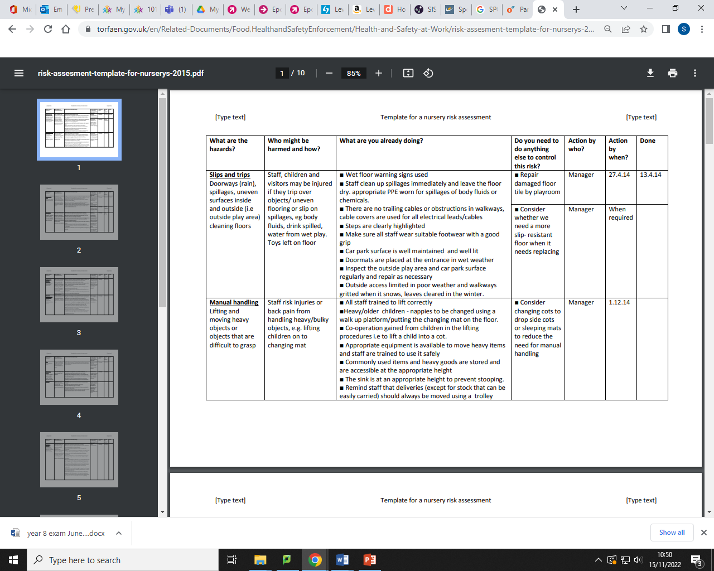

**What additional items need putting into place and why it makes my area safe**.

Safety gates to prevent children going to other areas where they would be at risk of scolding or be vulnerable to cleaning products which could cause poisoning.

Adapted seats for children aged 3-4 years with adult seats to prevent back injuries for those working with the children.

Checking all toys are age appropriate, follow BSI and CE guidelines

Safety Guards on all electrical outlets to ensure children cant put items or their fingers into them.

Wipeable chairs and tables and floor to keep the area hygienic with constant use to prevent spread of germs.

Foam floors to prevent injury   
  
Boxes to store away toys that are not being used, stored away out of reach of children to prevent climbing to obtain an item.

No equipment that can be climbed upon near the windows.

Locks on the windows to prevent children from opening them and falling out.

Poisoning

Sharp objects  
Sharp corners

Trip hazards

Objects close to walls

Small parts

Age appropriate equipment

Safety labels

Equipment near windows

Plug sockets

Blind cords

Unsecured doors/gates

Radiators

Spillages

Broken toys

Windows without locks

Cleaning equipment

Temperature

**Hazards in a nursery:**

Poisoning

Sharp objects  
  
Sharp corners

Trip hazards

Objects close to walls

Small parts

Age appropriate equipment

Safety labels

Equipment near windows

**Risk assessment**

A risk assessment is a document in which a person would look at any risks or hazards and how to counter act them in order to ensure every staff and adult are safe.

**Staff supervision** in areas where children are dealing with potentially harmful items such as musical instruments and crafting.

**Staff training in health and safety** so they can deal with children who have had accidents as well as knowing emergency skills such as CPR incase a child does choke/become burnt

Types of accidents:

Cuts and grazes

Burns

Drowning

Bumping head

Falling

Suffocating

Choking

Trapped fingers

Poisoning

Electric   
shocks

**RO58**

**Child Development**